# VPC TASK 01

1. Create VPC with 2 private and 2 public subnets.

**Step 1: Create a VPC**

* Name: **my-vpc-01**
* CIDR block: **172.168.0.0/24**  
  → This gives you **256 IP addresses**
* VPC created successfully.

**Step 2: Create Public Subnets**

I divided the VPC’s 256 IPs into 4 smaller blocks (each /26 has 64 IPs).

**Public Subnet 1**

* Name: **Public-subnet-01**
* CIDR: **172.168.0.0/26**  
  → First 64 IPs
* AZ: **eu-north-1a**

**Public Subnet 2**

* Name: **Public-subnet-02**
* CIDR: **172.168.0.64/26**  
  → Next 64 IPs
* AZ: **eu-north-1a**

.

**Step 3: Create Private Subnets**

**Private Subnet 1**

* Name: **Private-subnet-01**
* CIDR: **172.168.0.128/26**  
  → Next 64 IPs
* AZ: **eu-north-1b**

**Private Subnet 2**

* Name: **Private-subnet-02**
* CIDR: **172.168.0.192/26**  
  → Last 64 IPs
* AZ: **eu-north-1b**

**Step 4: Review VPC Resource Map**

You now have:

**1 VPC (my-vpc-01)**

**4 subnets**

* 2 Public (in AZ a)
* 2 Private (in AZ b)

**All 4 subnets linked to one route table**

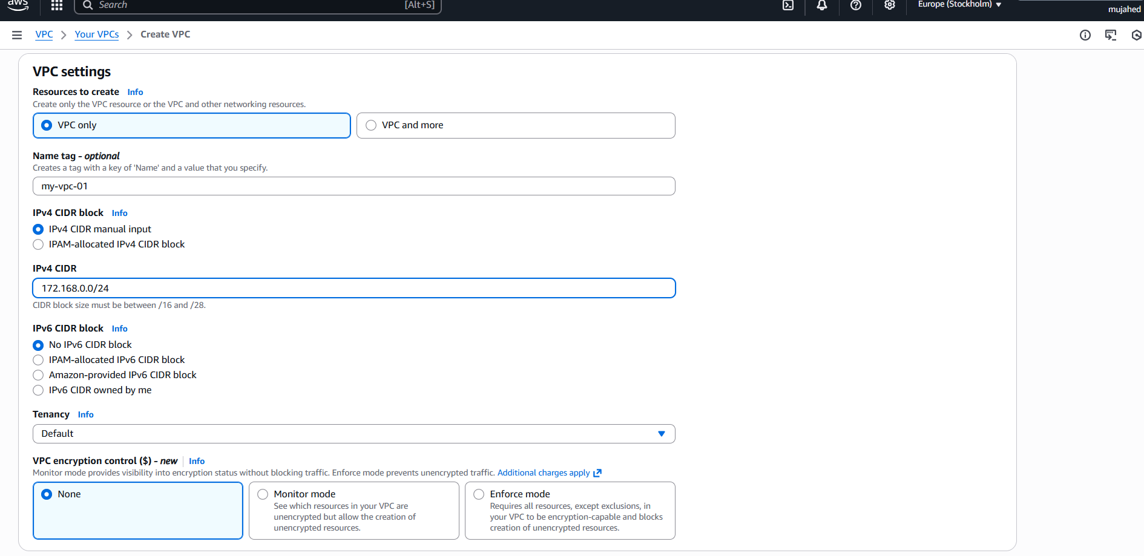

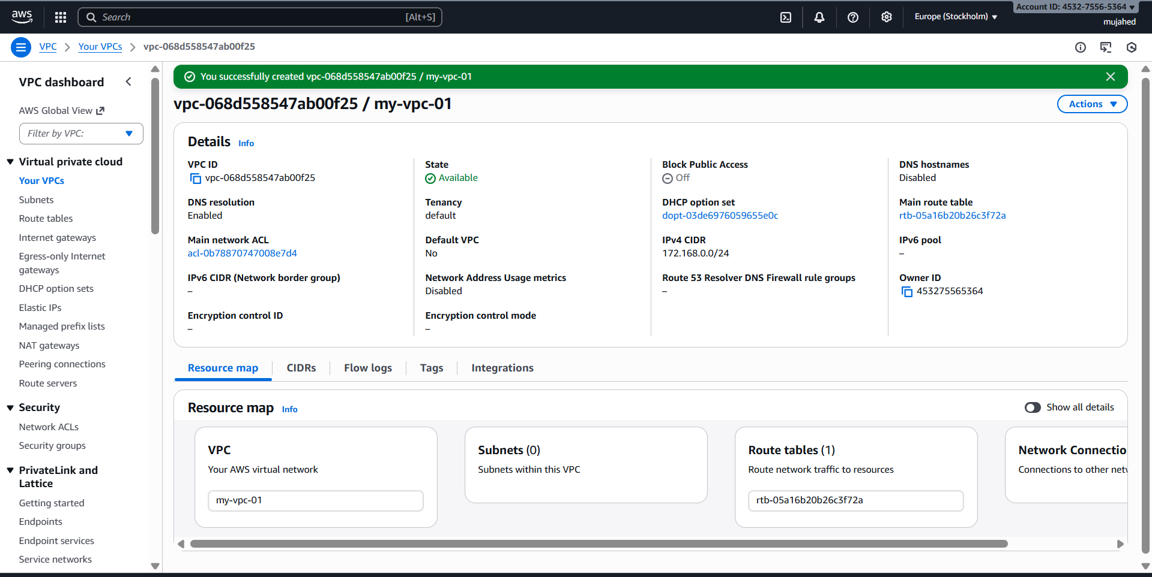

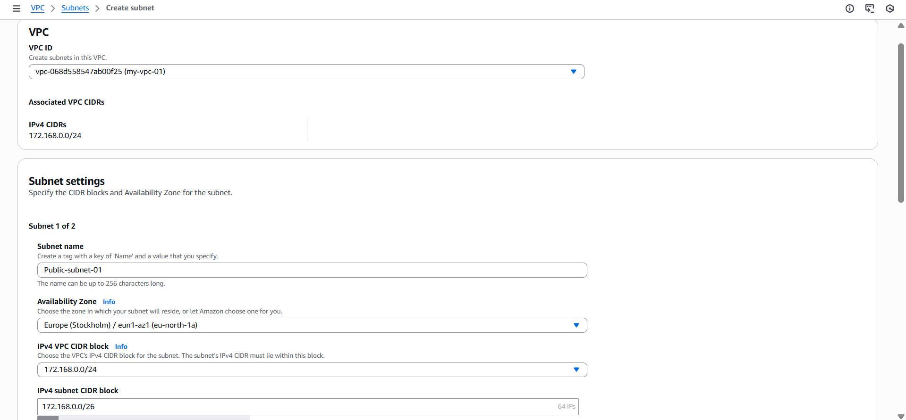

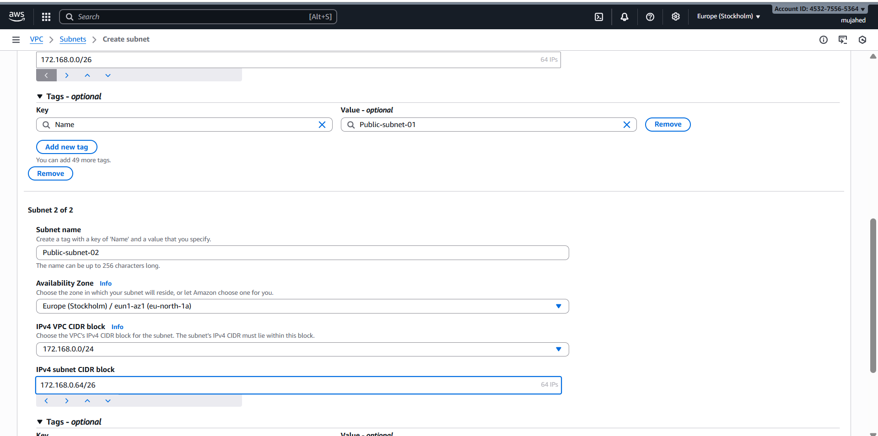

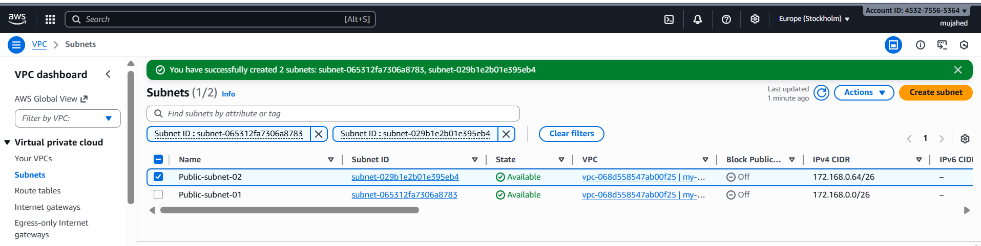

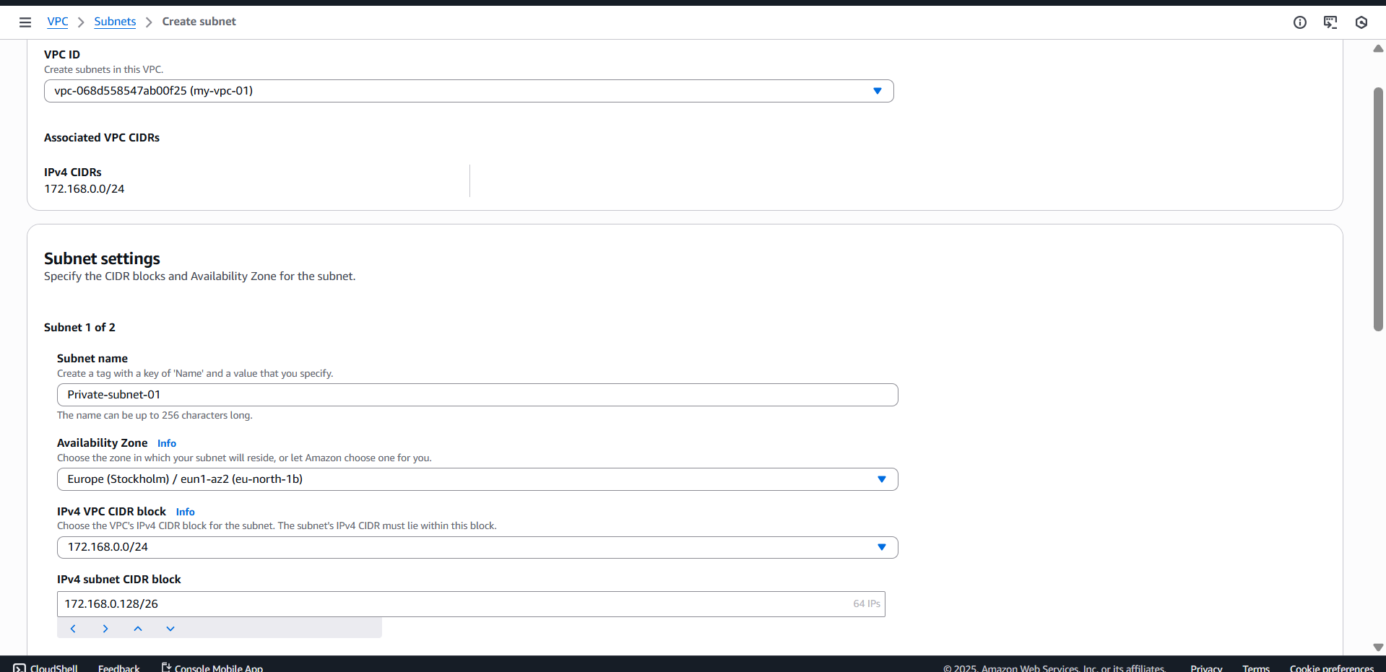

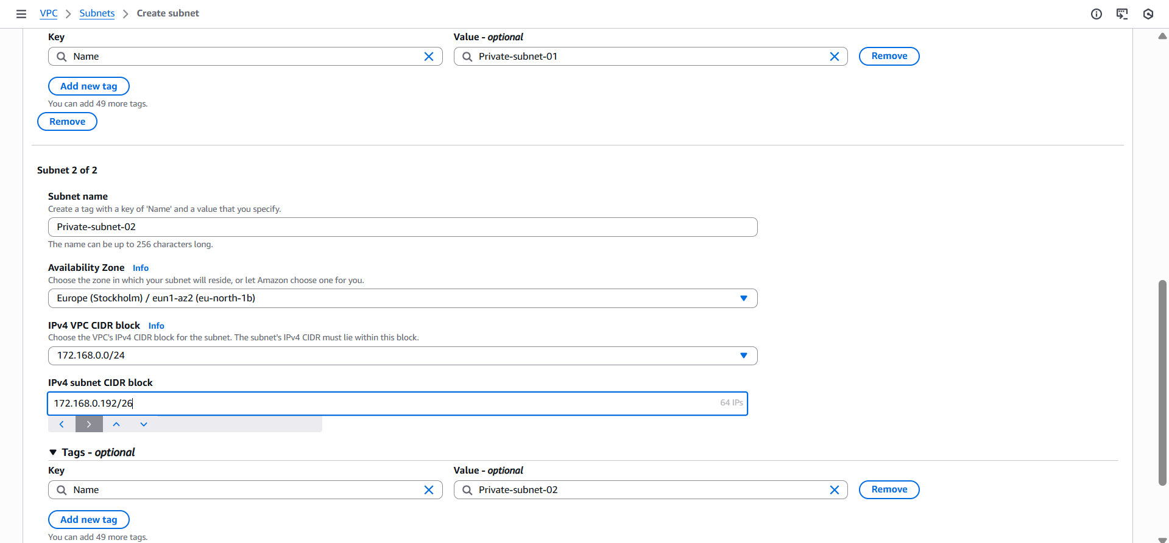

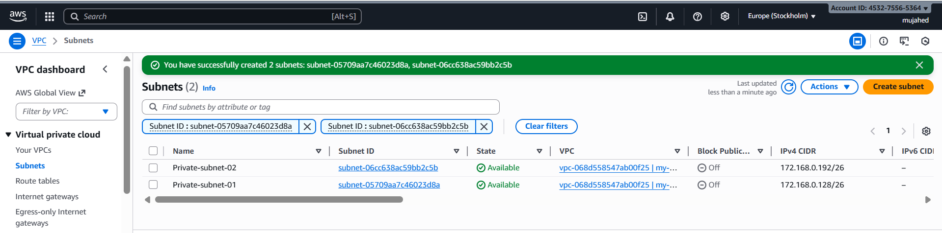

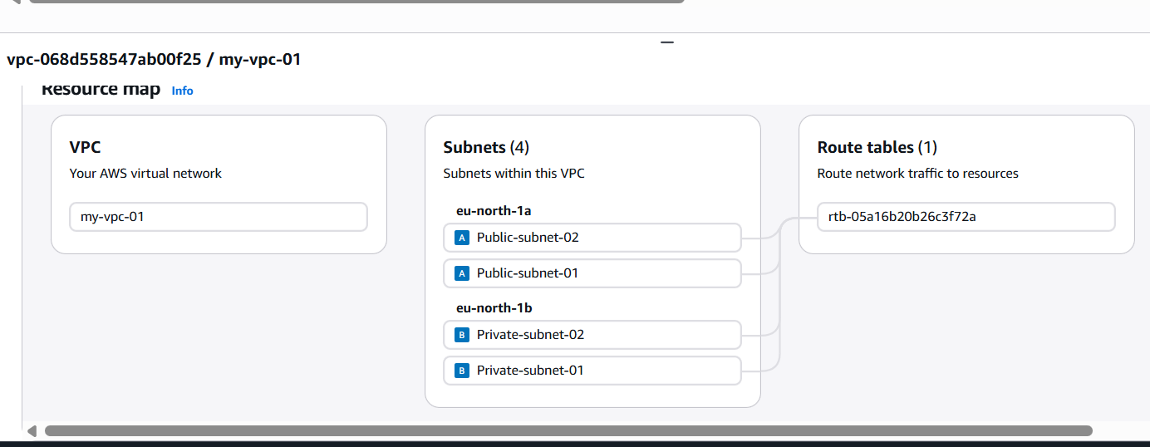

1. Enable DNS Hostname in VPC.

* Go to the **AWS Console** → **VPC** service.
* In the left menu, click **Your VPCs**.
* Select your VPC (example: my-vpc-01).
* At the bottom, go to the **Details** tab.
* Click **Edit VPC settings**.
* Enable the checkbox:  
   **DNS hostnames**
* Ensure **DNS resolution** is also enabled.
* Click **Save changes**.

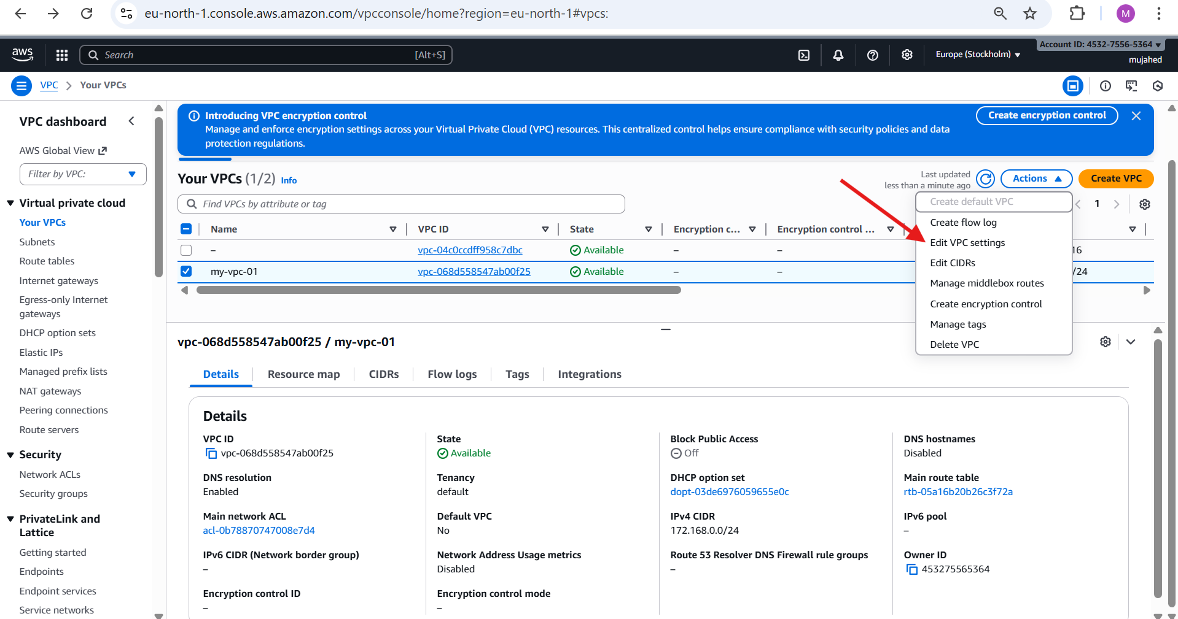

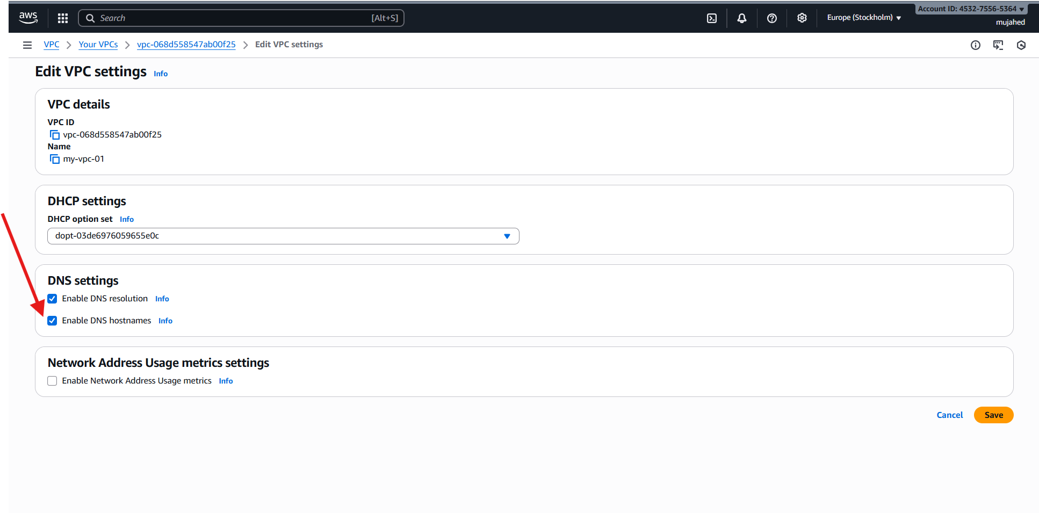

1. Enable Auto Assign Public IP in 2 public subnets.

**Go to the VPC Console**

* Open **AWS Console → VPC → Subnets**.

**. Select Public Subnet 1**

* Click on your subnet:  
  **Public-subnet-01**
* Choose the **Subnet actions** dropdown.
* Click **Edit subnet settings**.

**. Enable Auto-Assign Public IPv4**

* Tick the checkbox:  
  ✔ **Enable auto-assign public IPv4 address**
* Click **Save**.

**. Repeat for Public Subnet 2**

* Select your second subnet:  
  **Public-subnet-02**
* Again click:
  + **Edit subnet settings**
  + Enable **Auto-assign public IPv4**
  + Save.

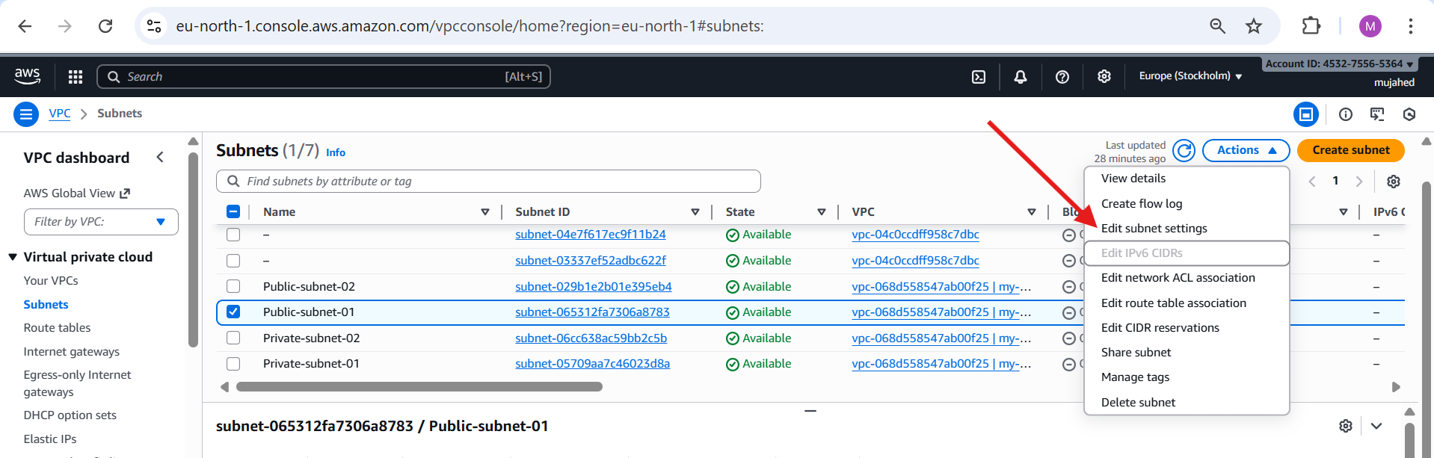

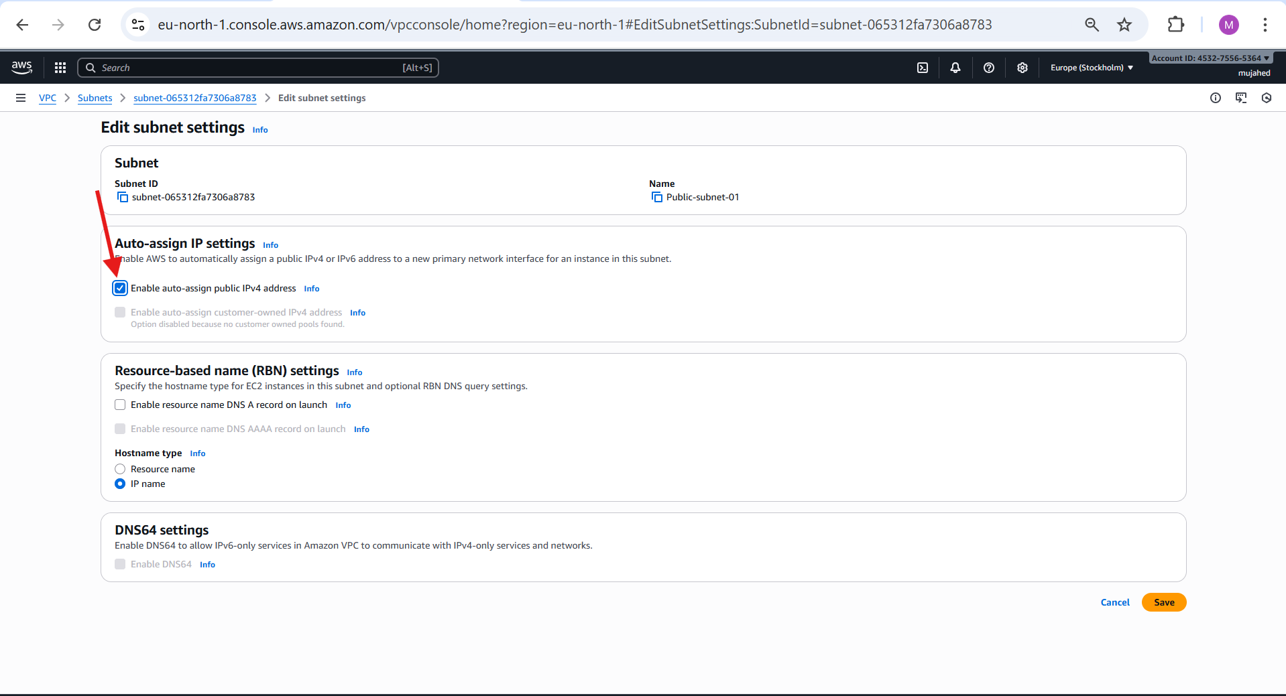

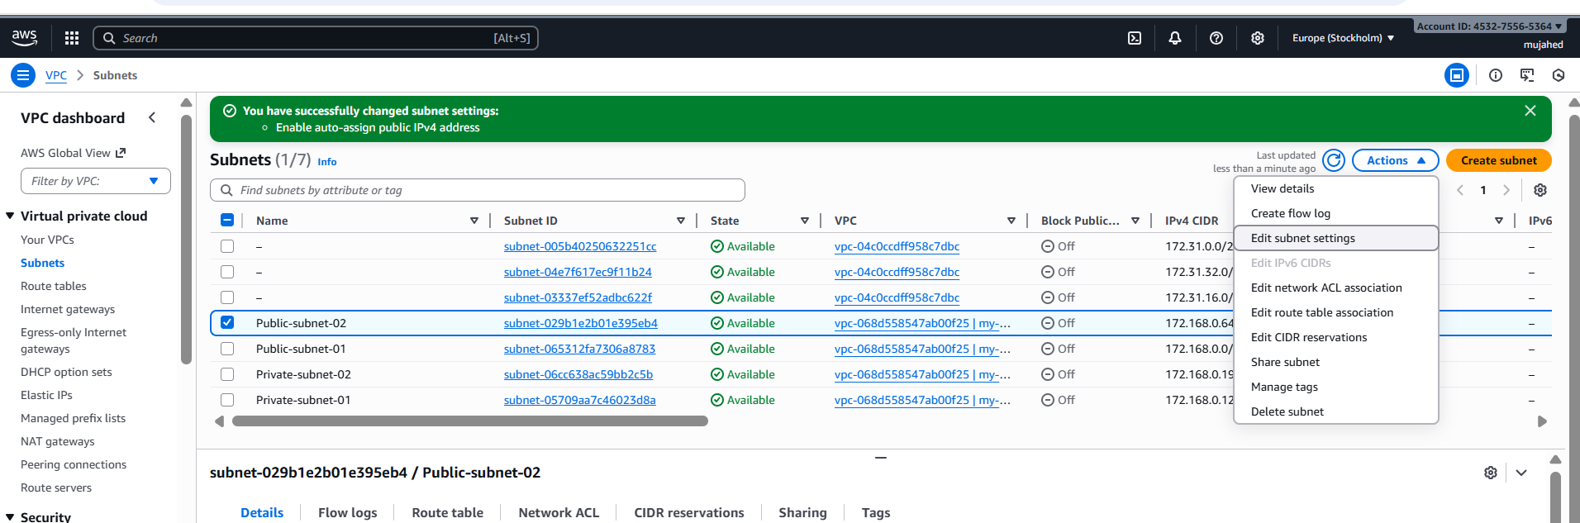

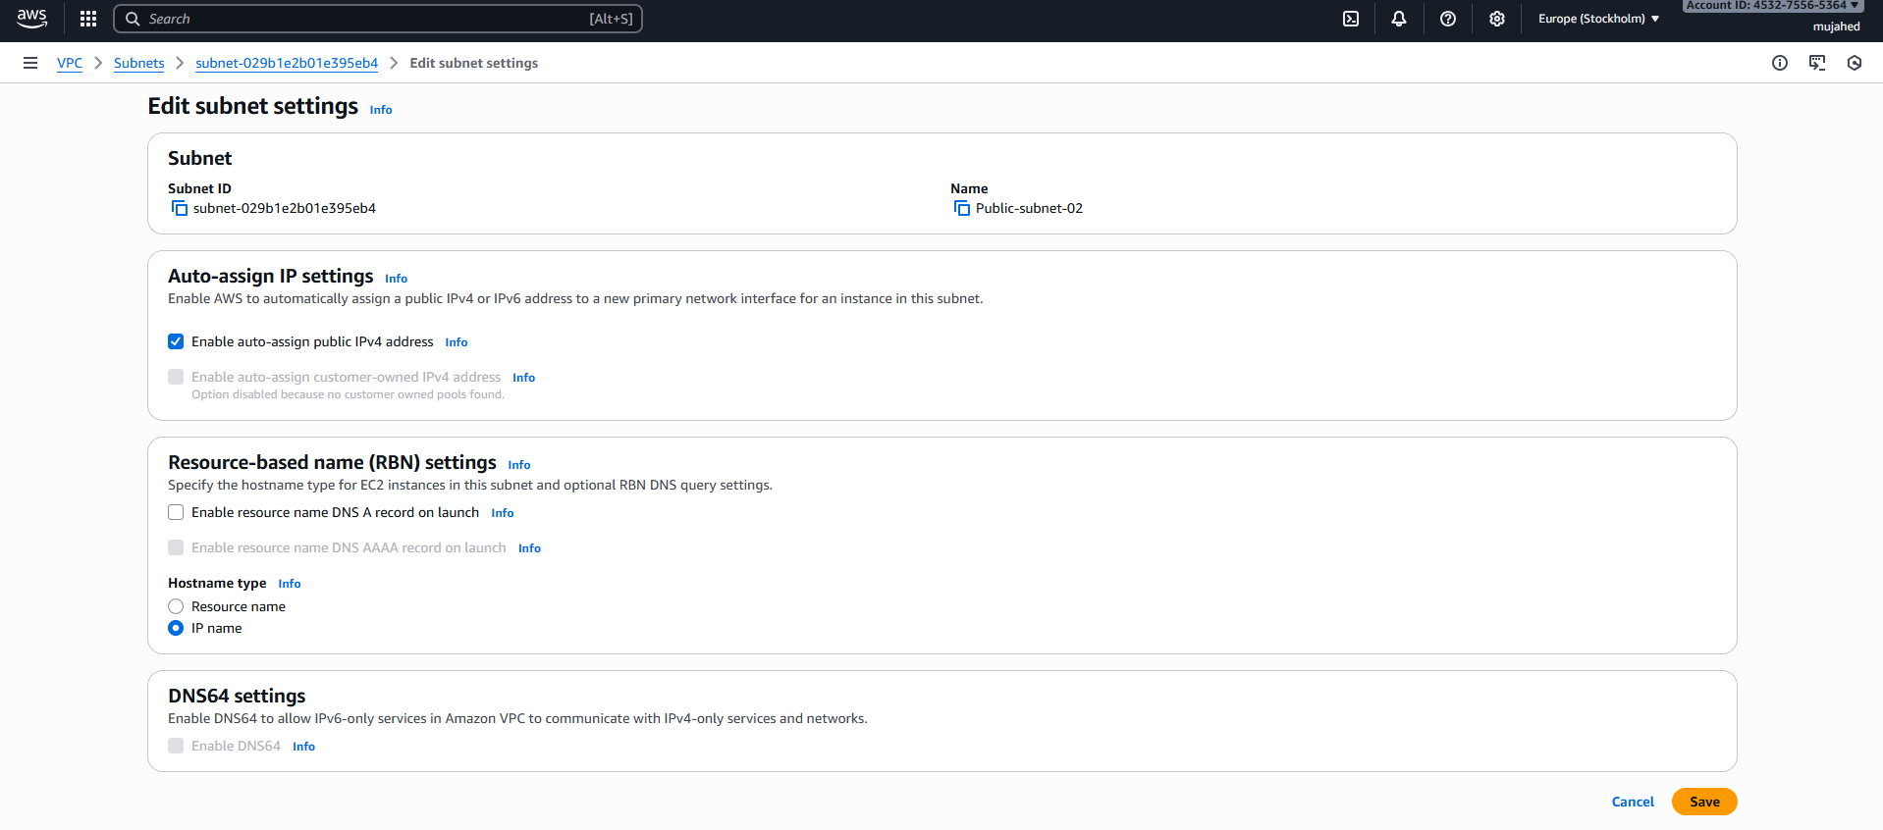

1. Add 2 private subnets in private route table.

**Step 1: Go to Route Tables**

* Open **AWS Console → VPC → Route Tables**.

**Step 2: Select Your Route Table**

**Step 3: Open Subnet Associations**

* In the bottom panel → select **Subnet associations** tab.
* Click **Edit subnet associations**.

**Step 4: Select Both Private Subnets**

Tick the checkboxes for:

* **Private-subnet-01**
* **Private-subnet-02**

**Step 5: Save**

* Click **Save associations**.

Now both private subnets are attached to the Private Route Table

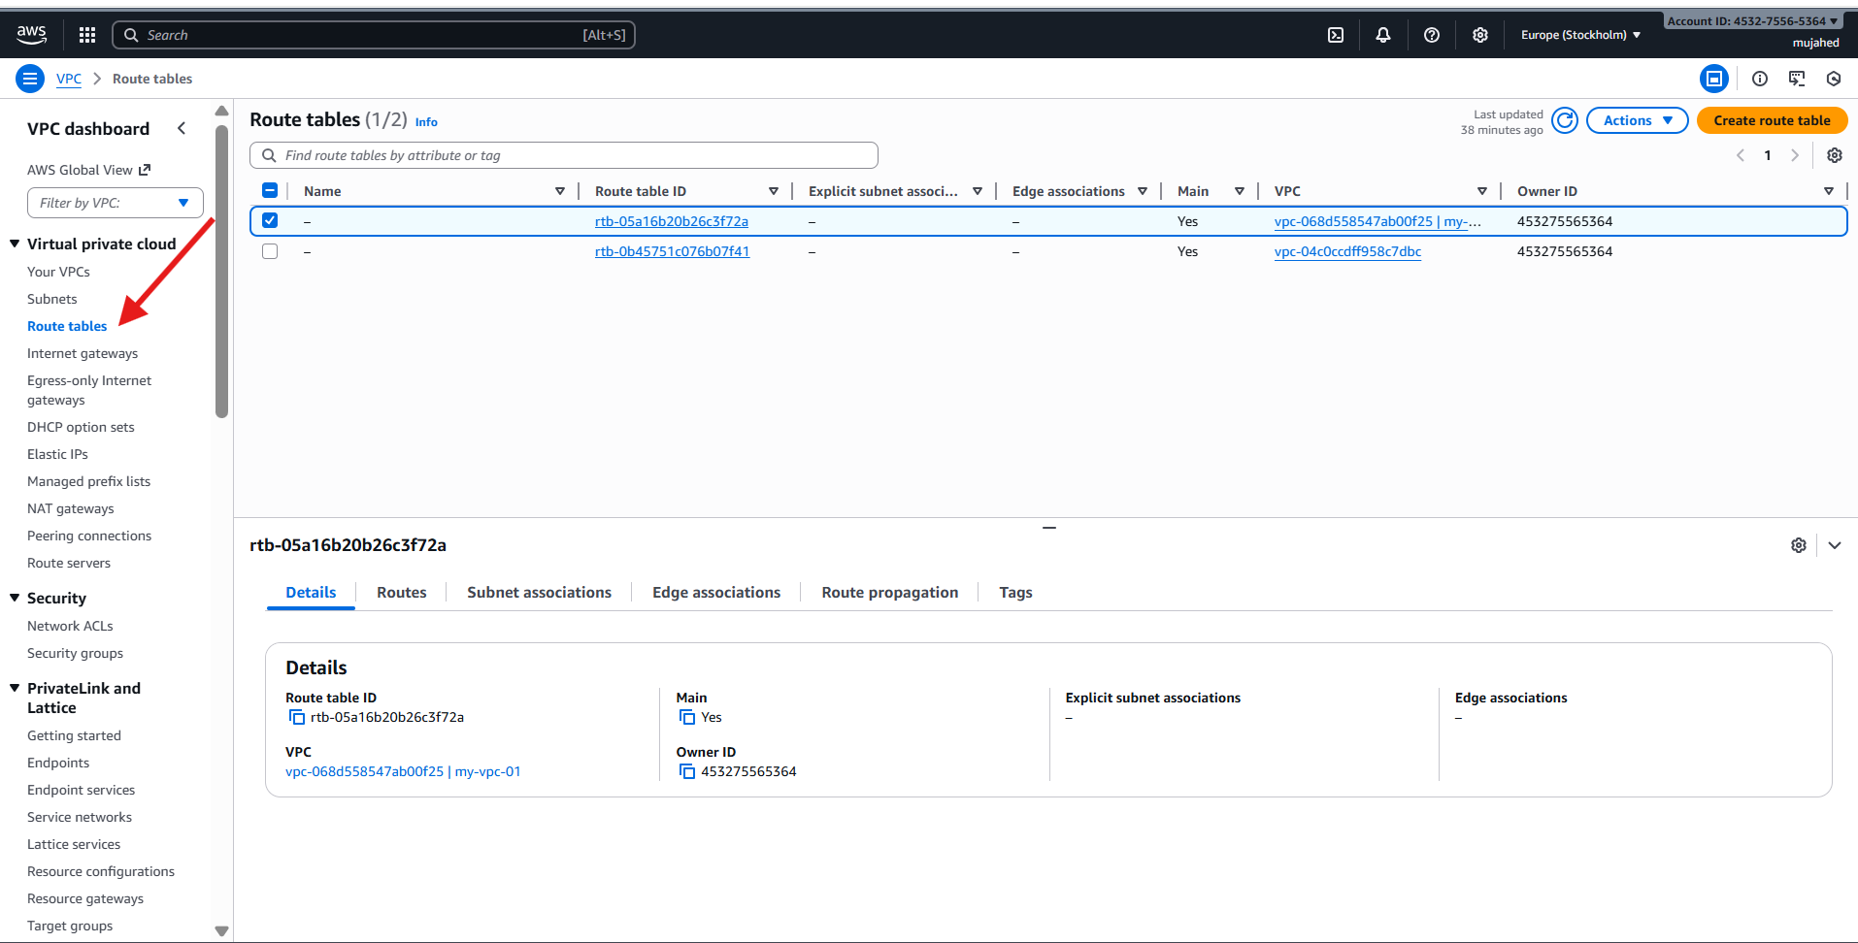

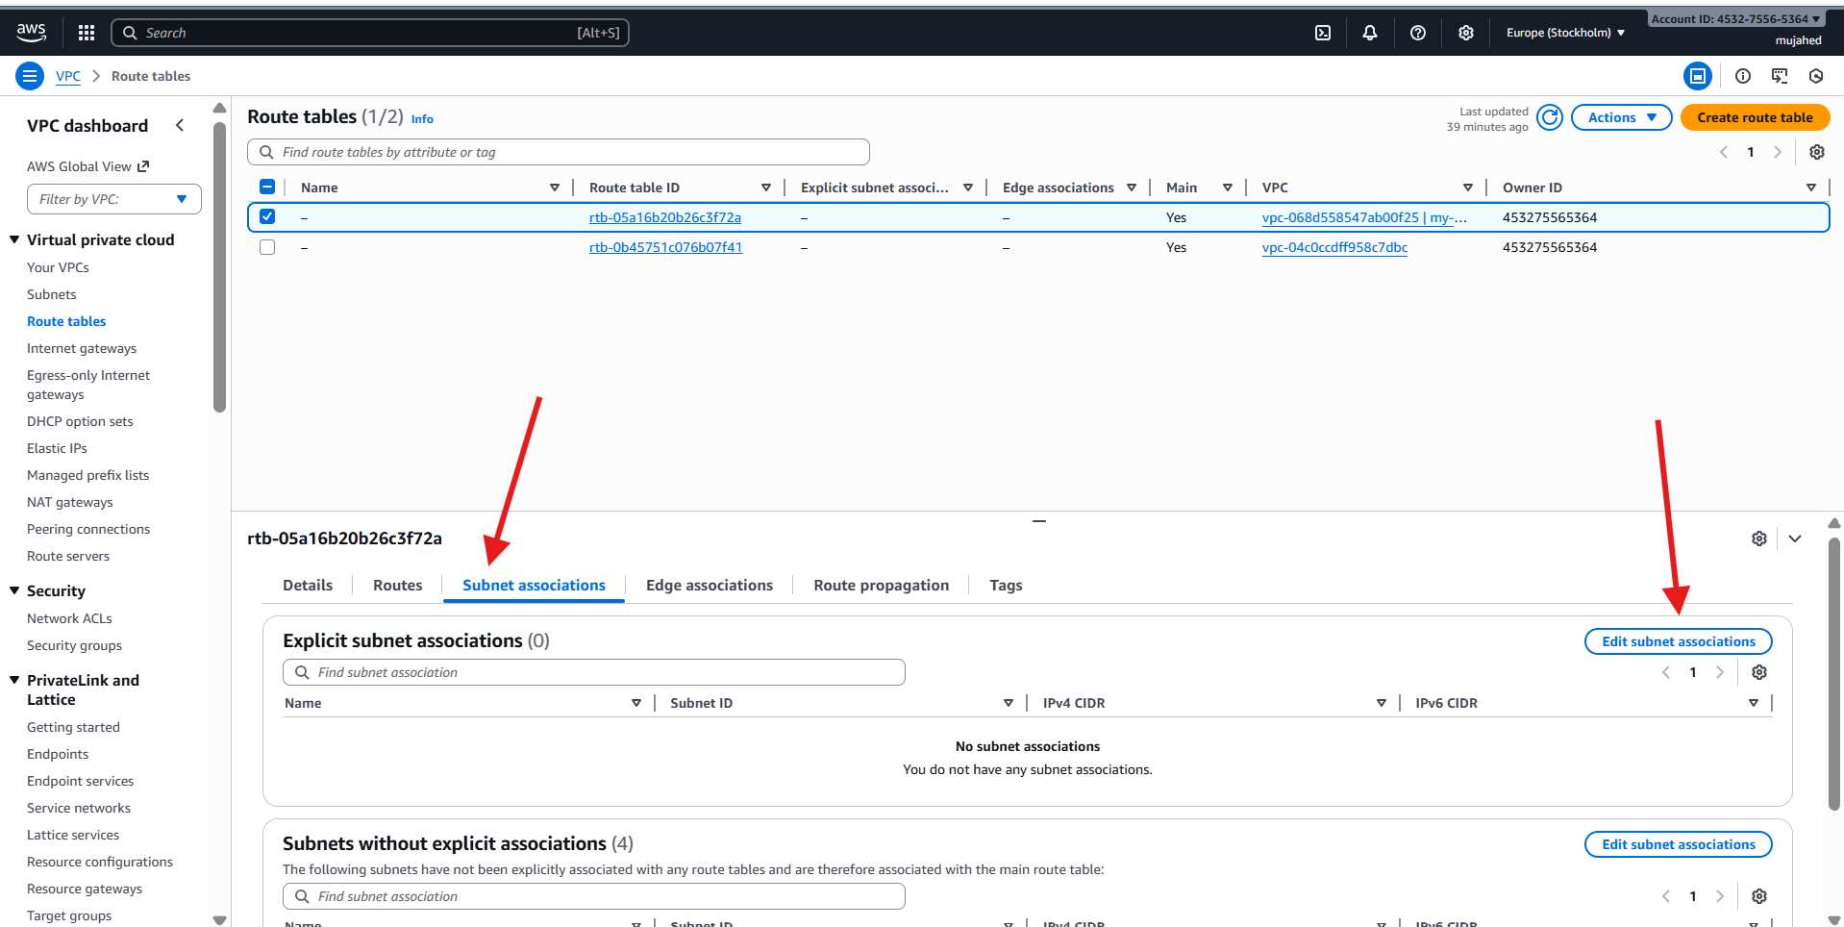

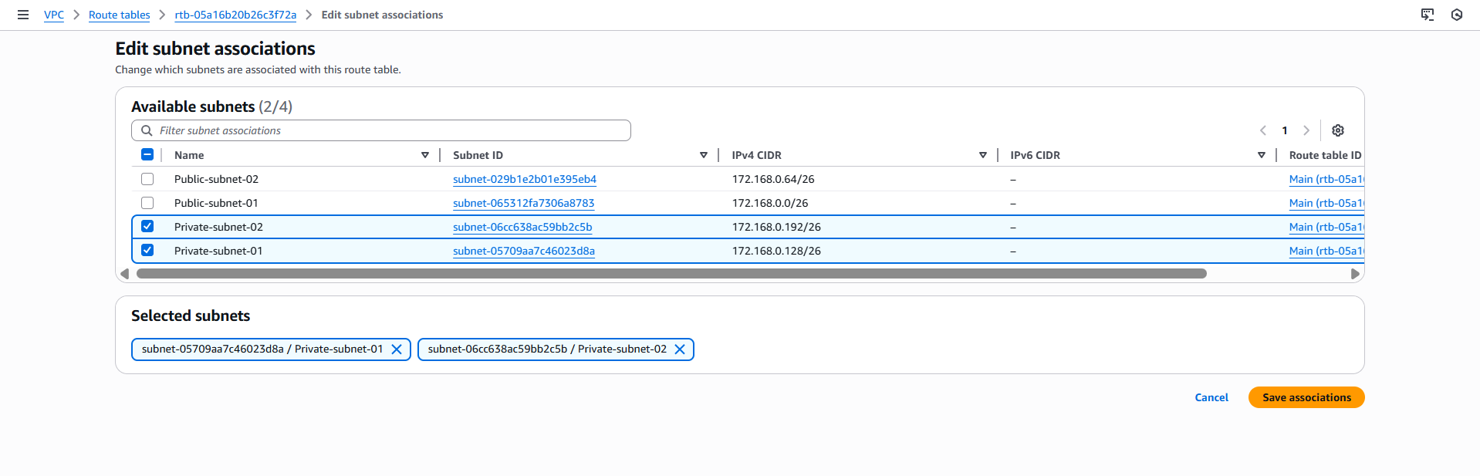

1. Add 2 public subnets in public route table.

**Step 1: Go to Route Tables**

* Open **AWS Console → VPC → Route Tables**.

**Step 2: Select Your Route Table**

**Step 3: Open Subnet Associations**

* In the bottom panel → select **Subnet associations** tab.
* Click **Edit subnet associations**.

**Step 4: Select Both Public Subnets**

Tick the checkboxes for:

* **Public-subnet-01**
* **Public-subnet-02**

**Step 5: Save**

* Click **Save associations**.

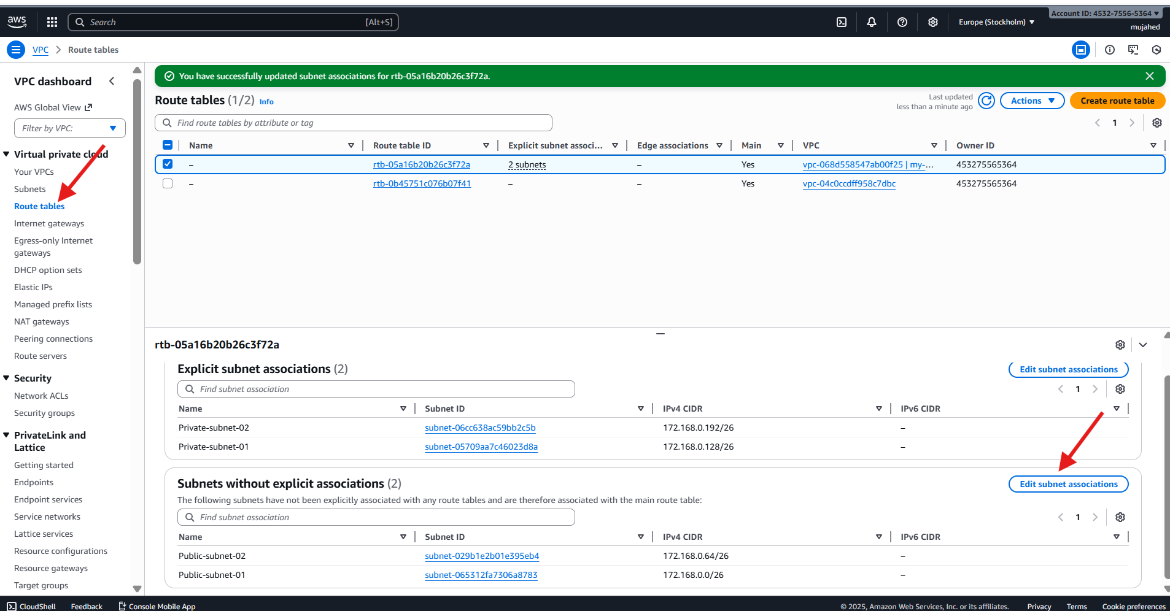

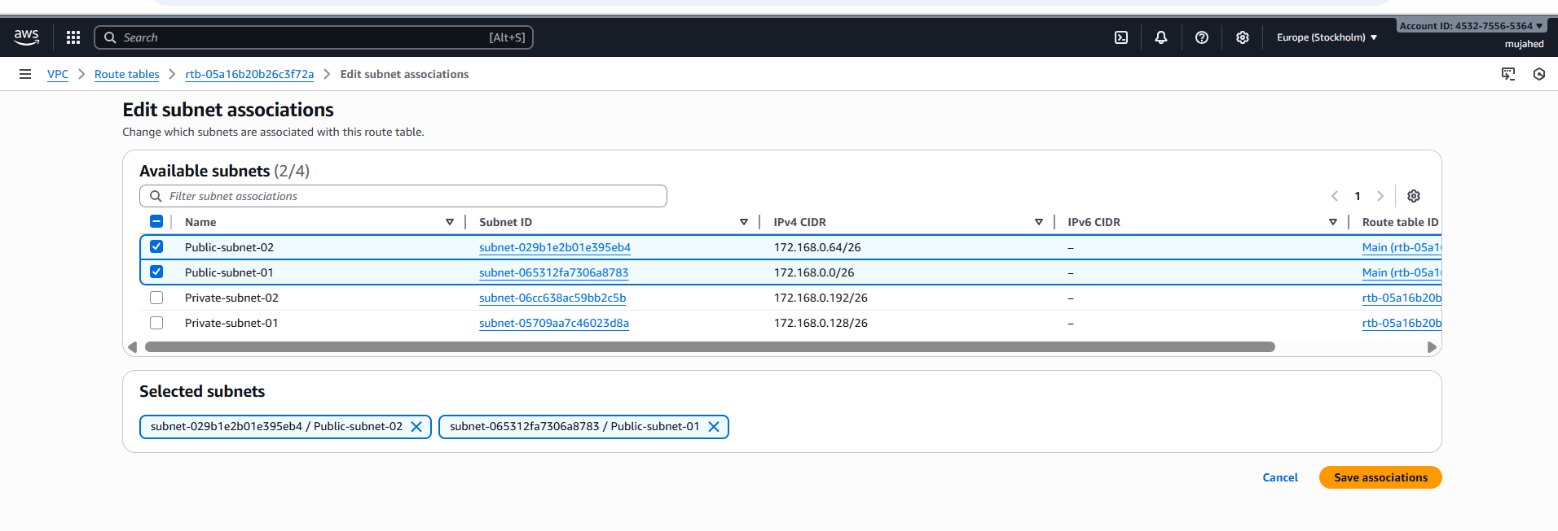

1. Public route table will have the routes to internet and local.

* Go to **VPC Console → Internet Gateways**
* Click **Create Internet Gateway**
* Name: MyIGW
* After creating → Select it
* Click **Actions → Attach to VPC**
* Choose your VPC (my-vpc-01) → **Attach**
* **VPC → Route Tables → public-rt → Routes → Edit routes**
* Add:

| **Destination** | **Target** |
| --- | --- |
| 0.0.0.0/0 | Select **Internet Gateway** |

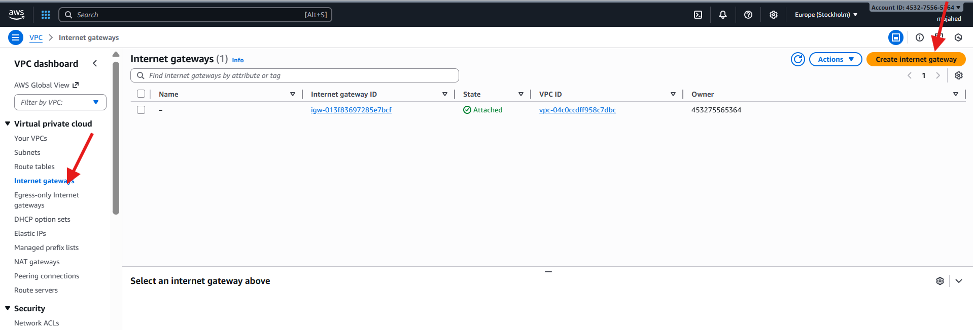

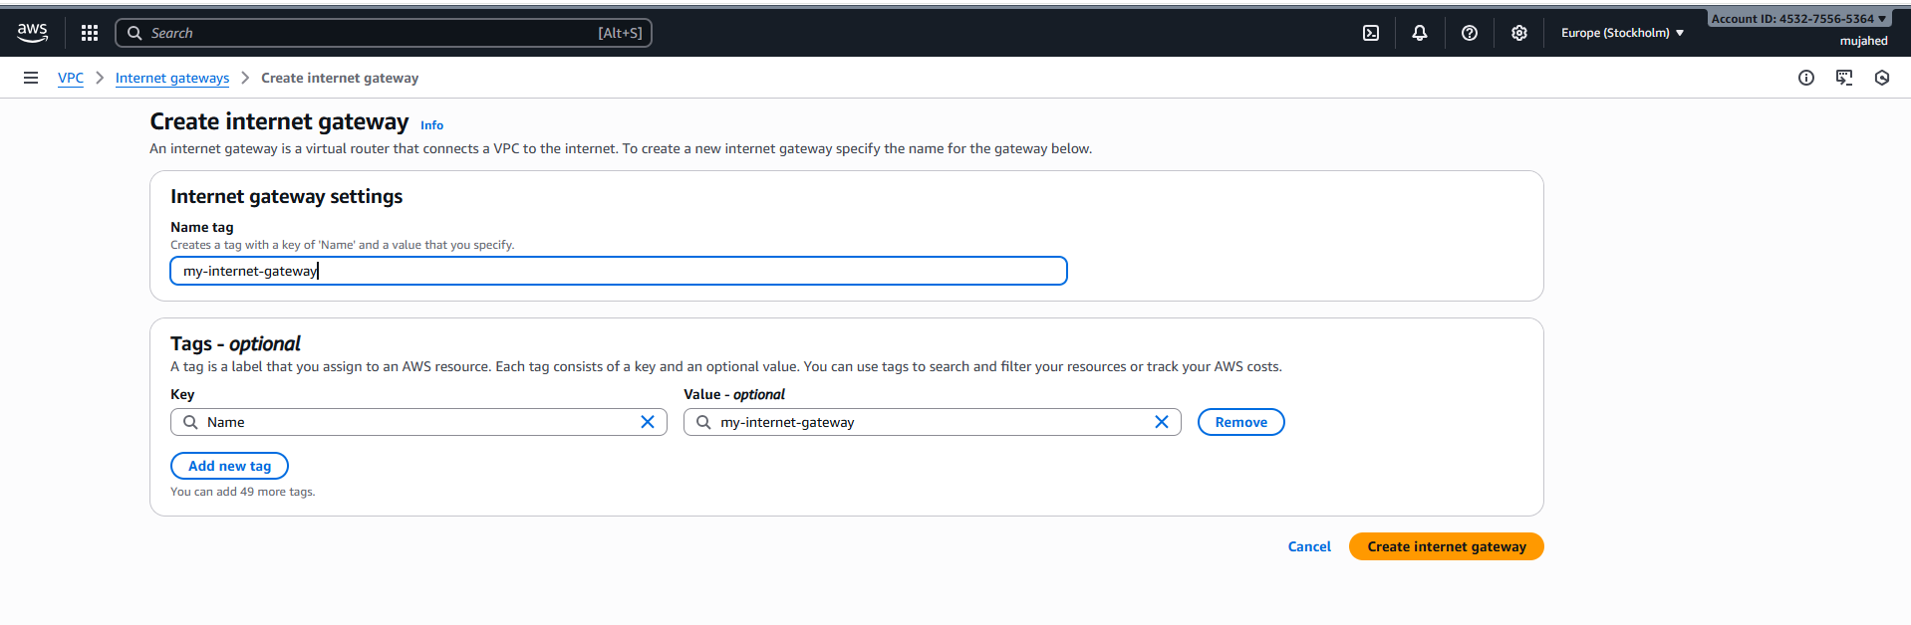

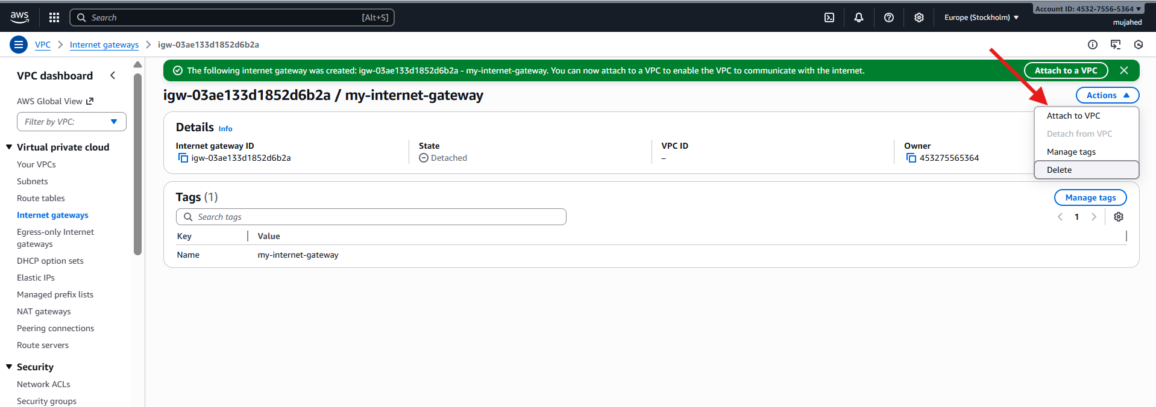 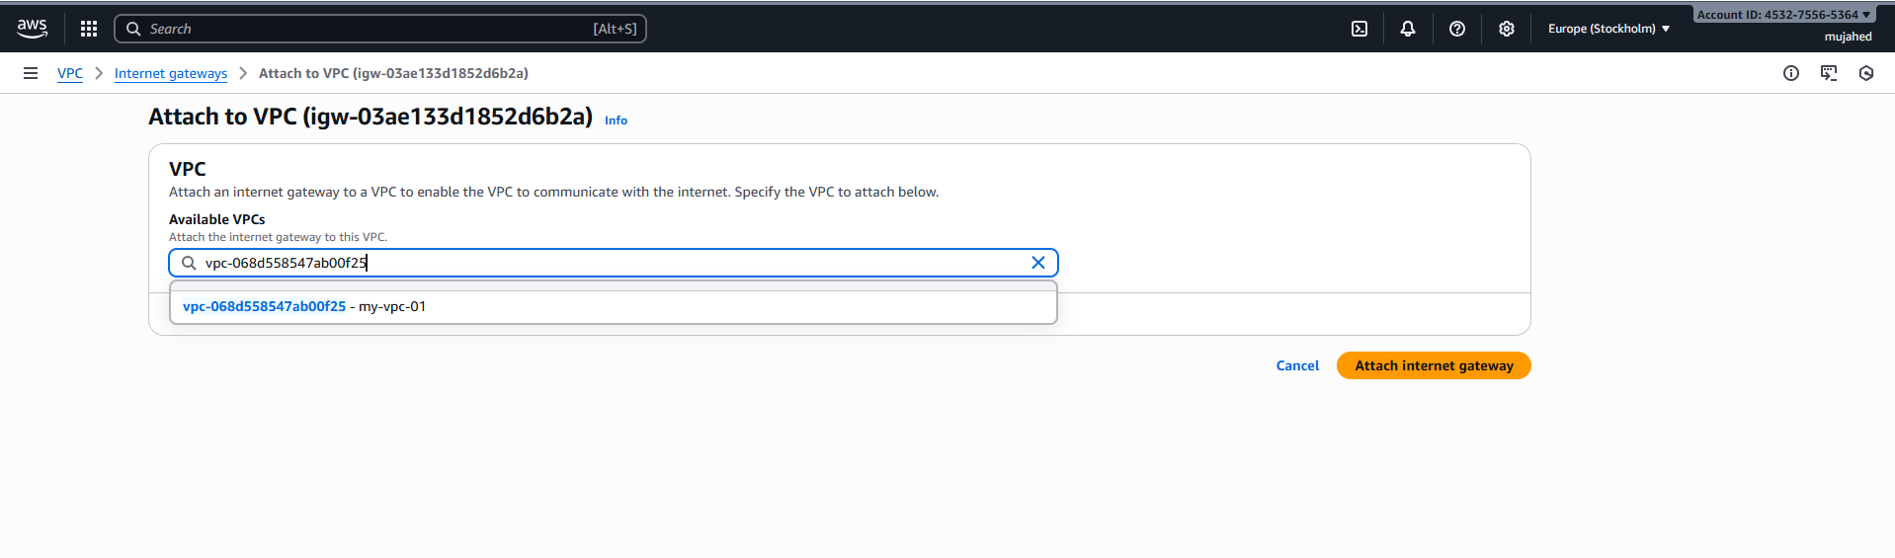

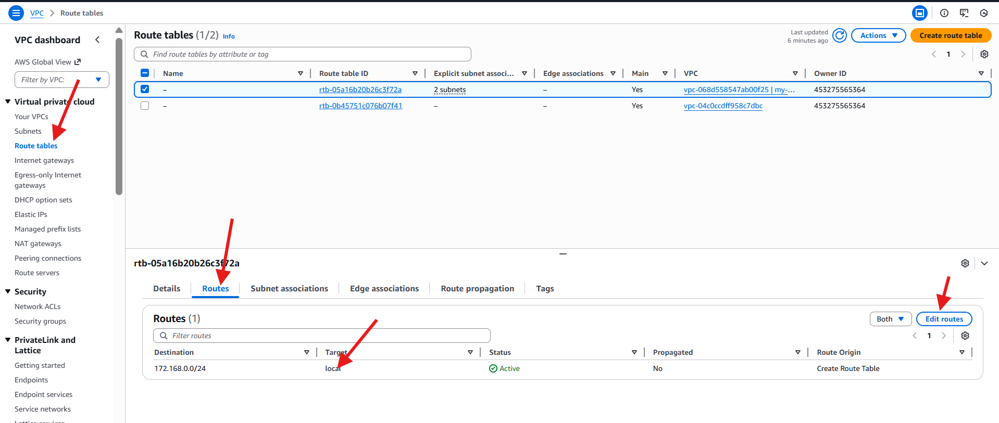

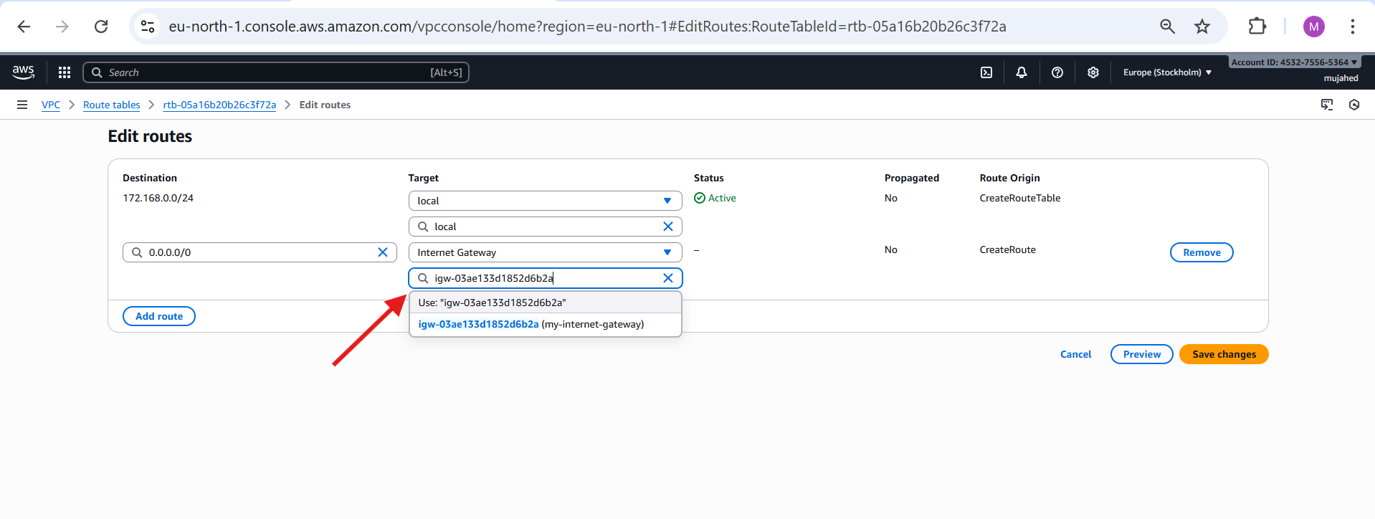

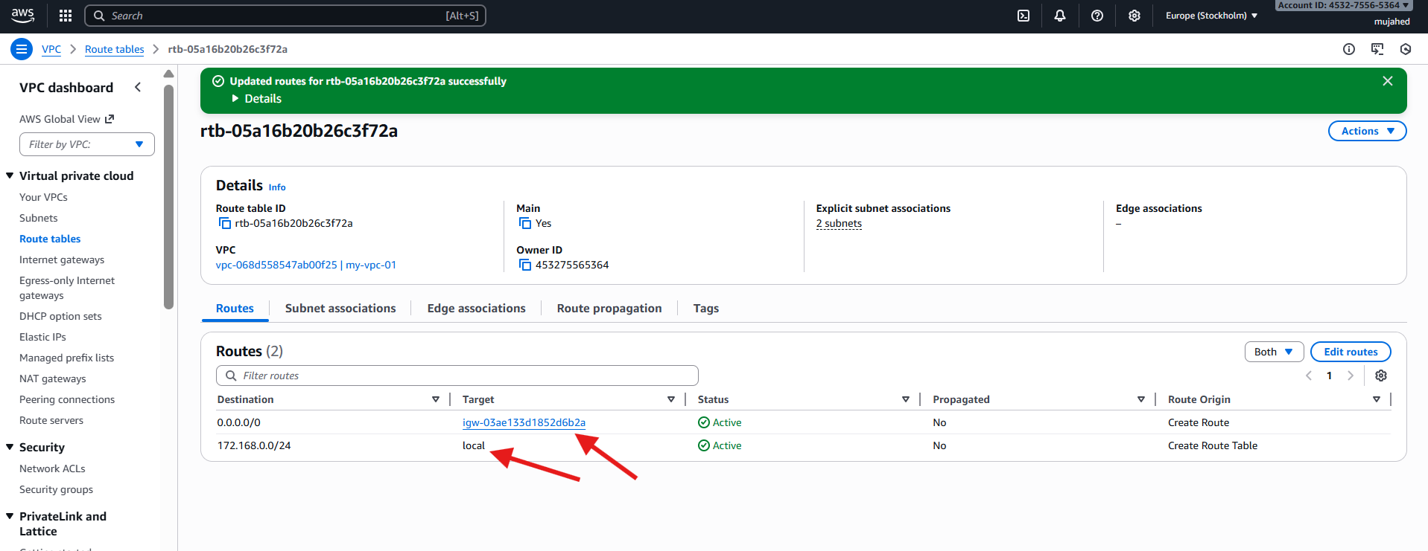

1. Create EC2 in public subnet with t2.micro and install PHP.

* Open the AWS console in your browser and launch a new EC2 instance named **php-server**.
* Select the **Amazon Linux**  AMI
* Under **Network Settings**, choose your **VPC** and select the **public subnet**.
* In the **Security Group**, add the following inbound rules:
* **SSH (port 22)**
* **HTTP (port 80)**
* Launch the instance and connect to it using SSH.
* Run:
* sudo yum update -y
* sudo yum install httpd -y
* systemctl status httpd
* sudo systemctl start httpd
* sudo yum install -y php php-cli php-mysqlnd
* sudo systemctl restart httpd
* then with public ip check on browser

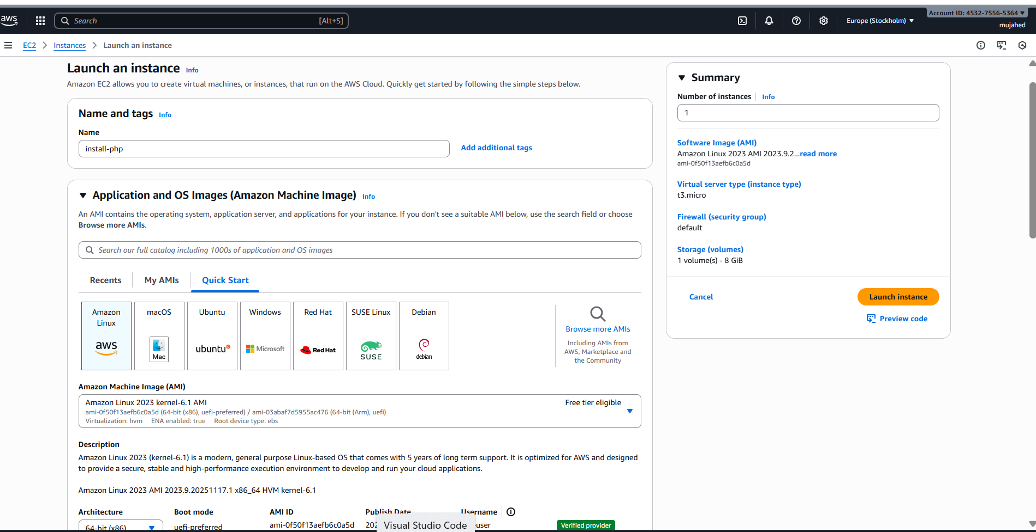

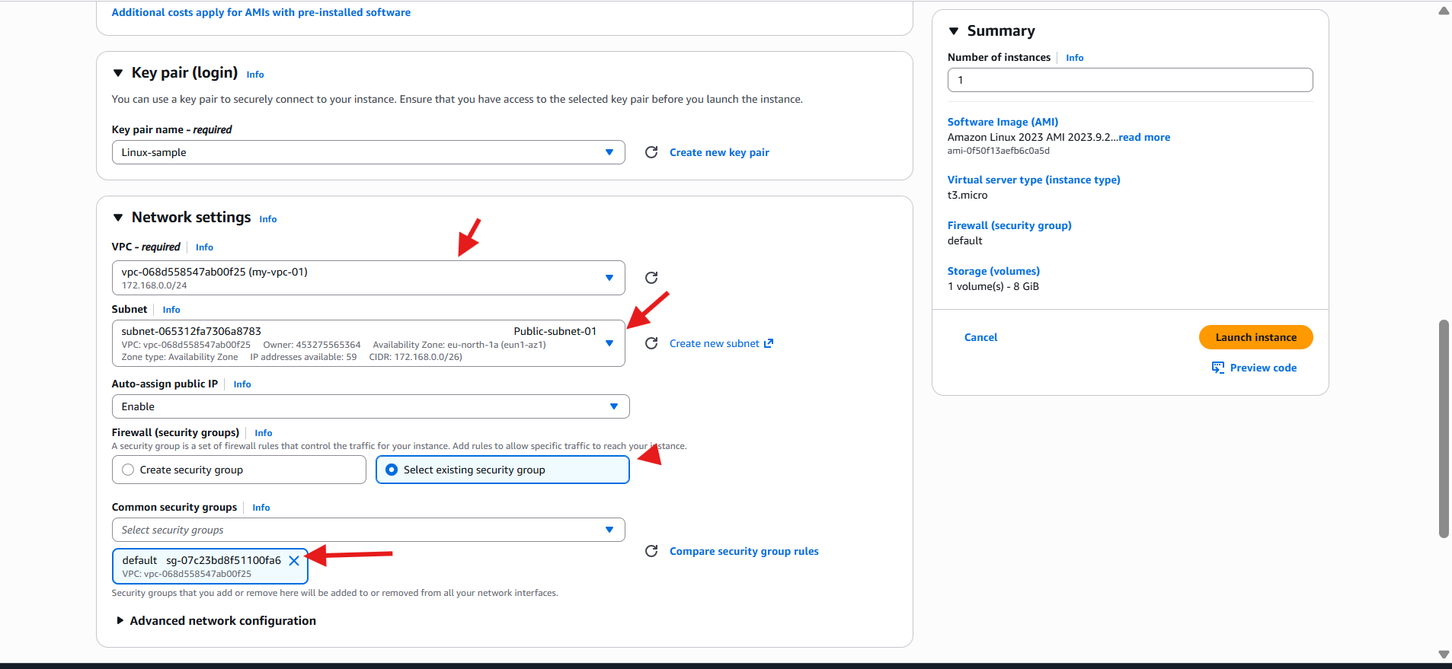

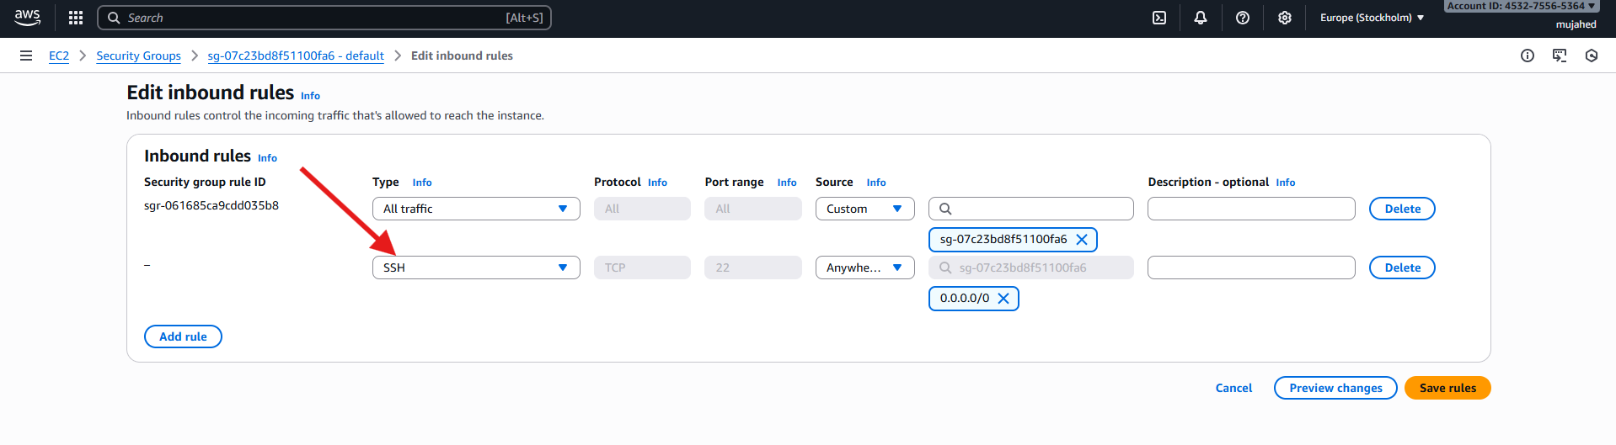

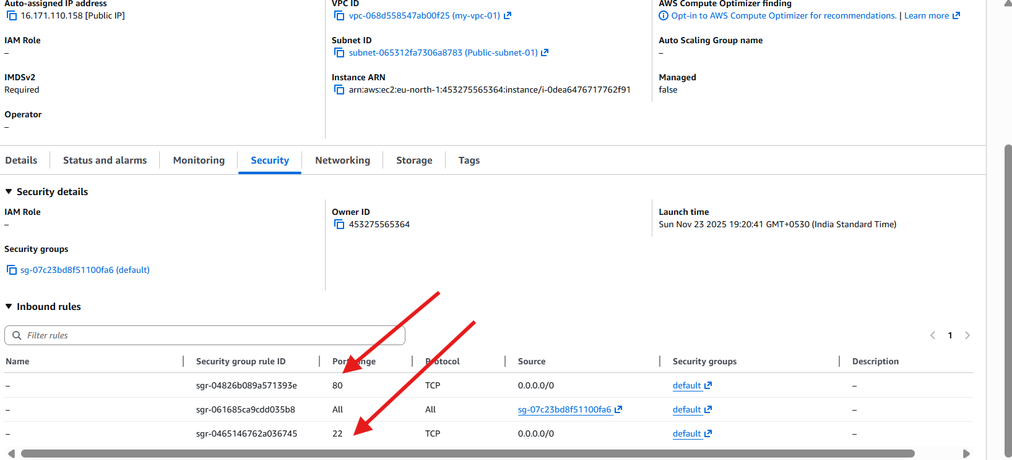

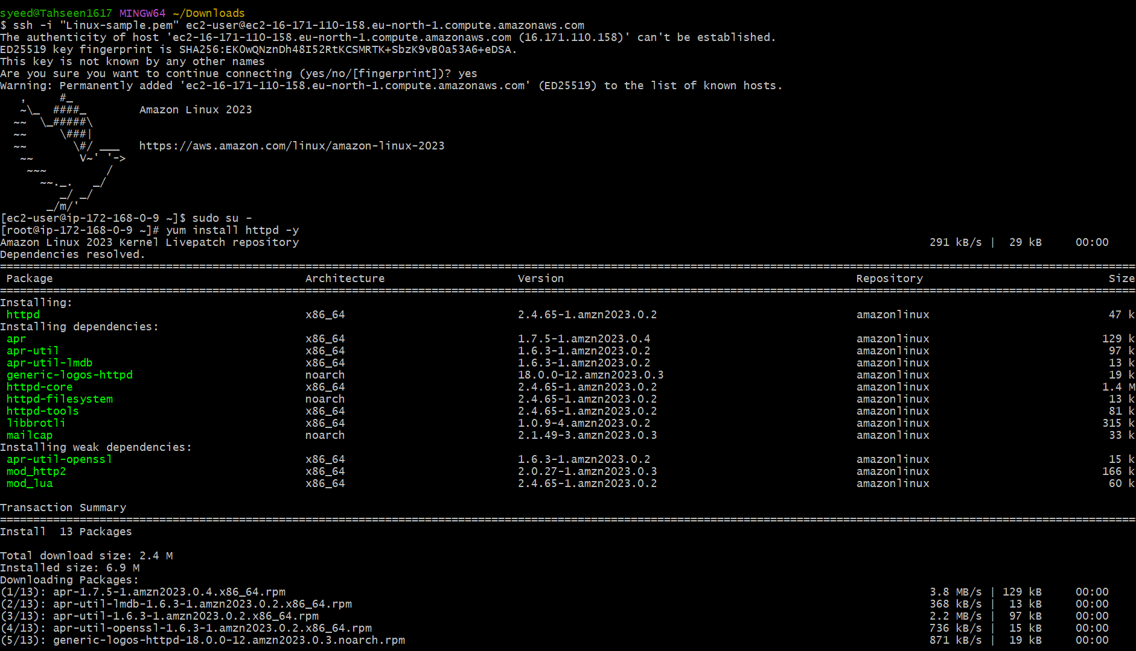

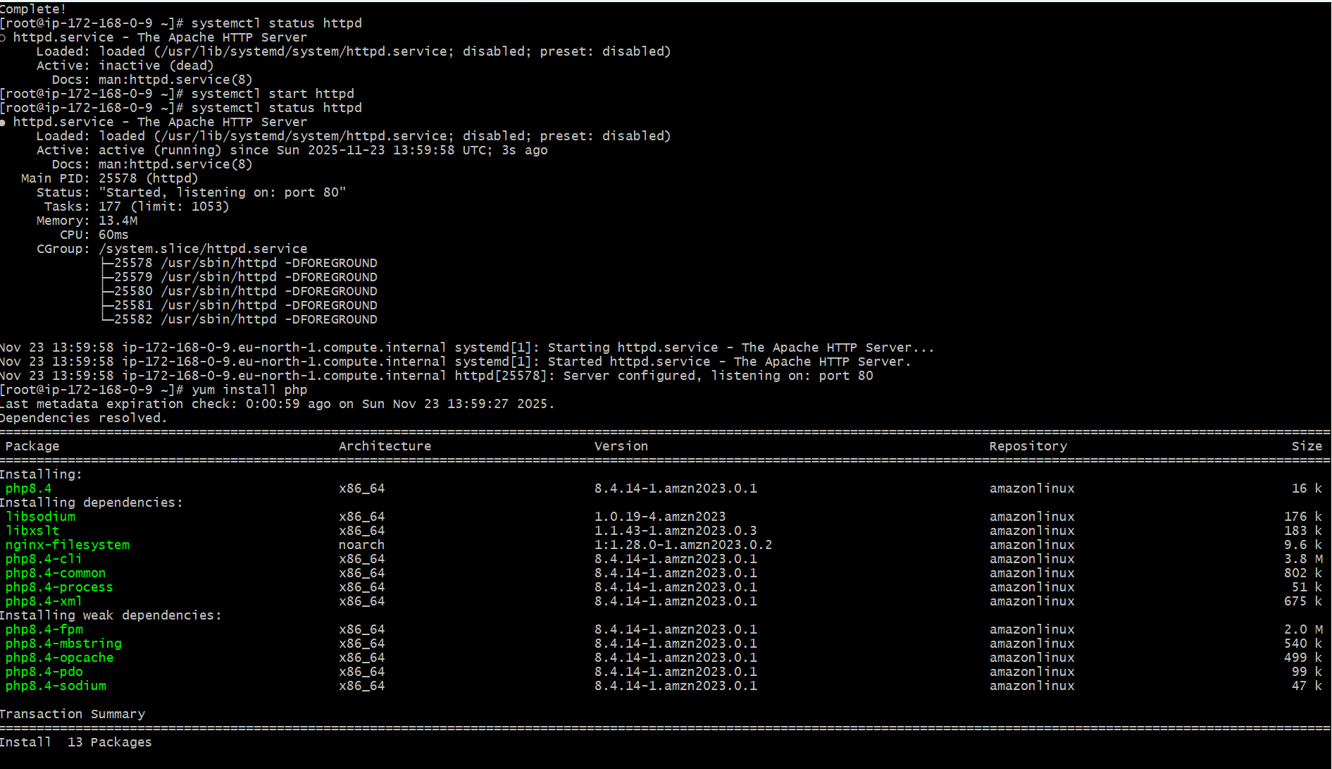

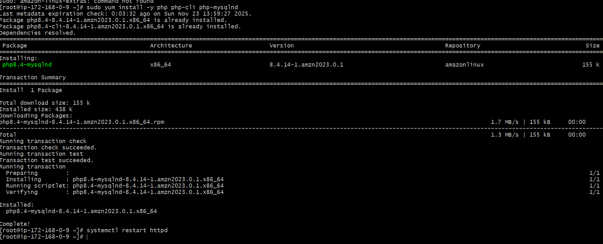

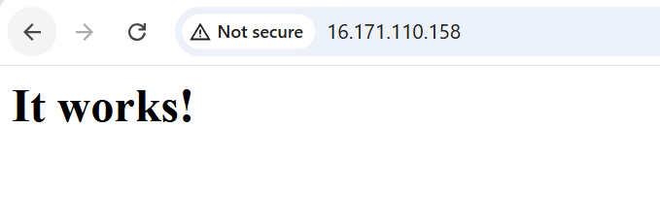

1. Configure NAT gateway in public subnet and connect to private instance.

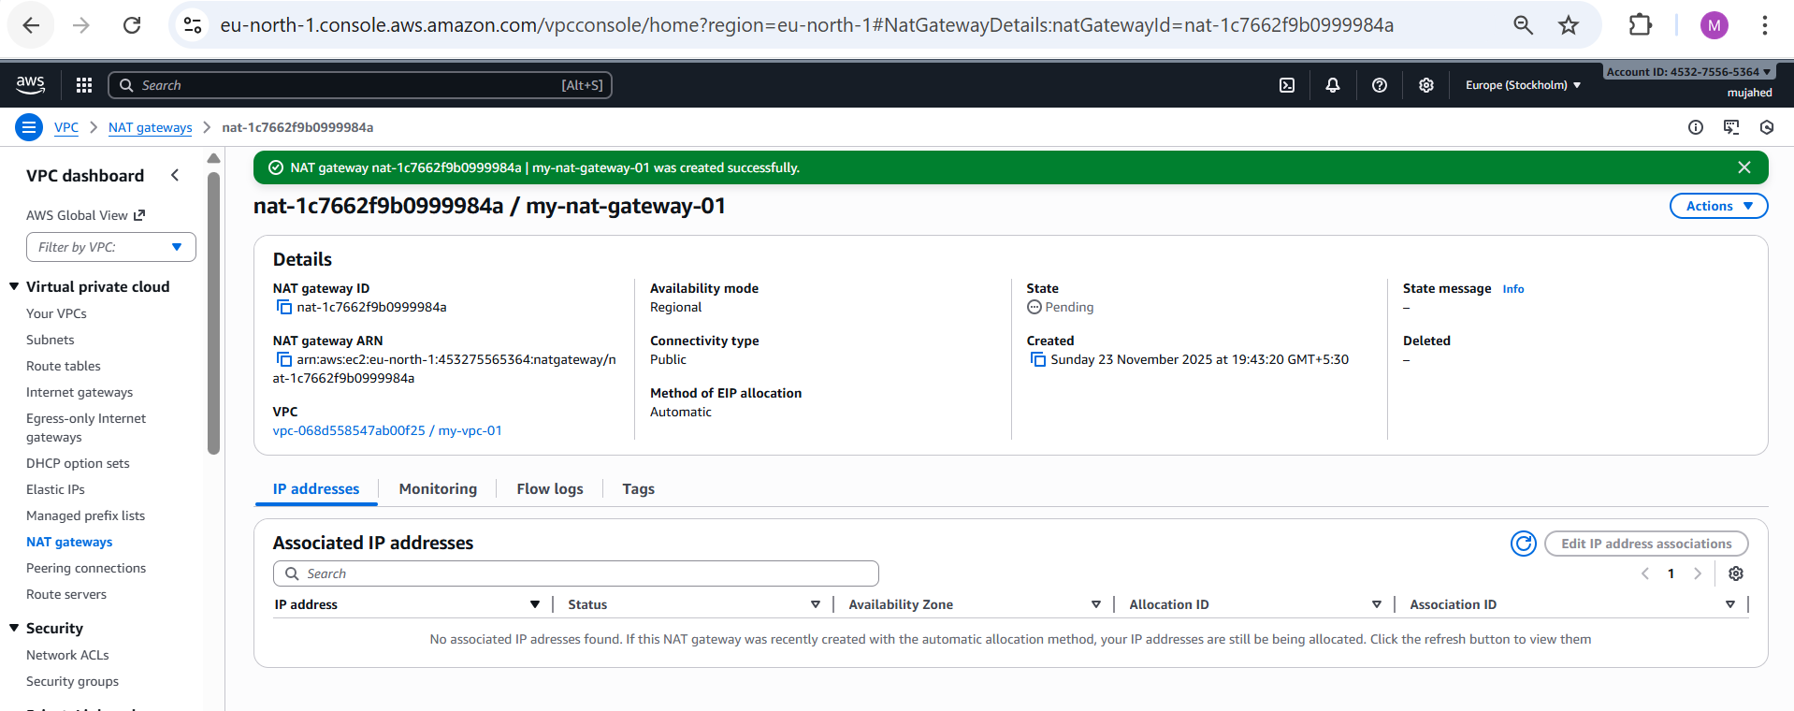

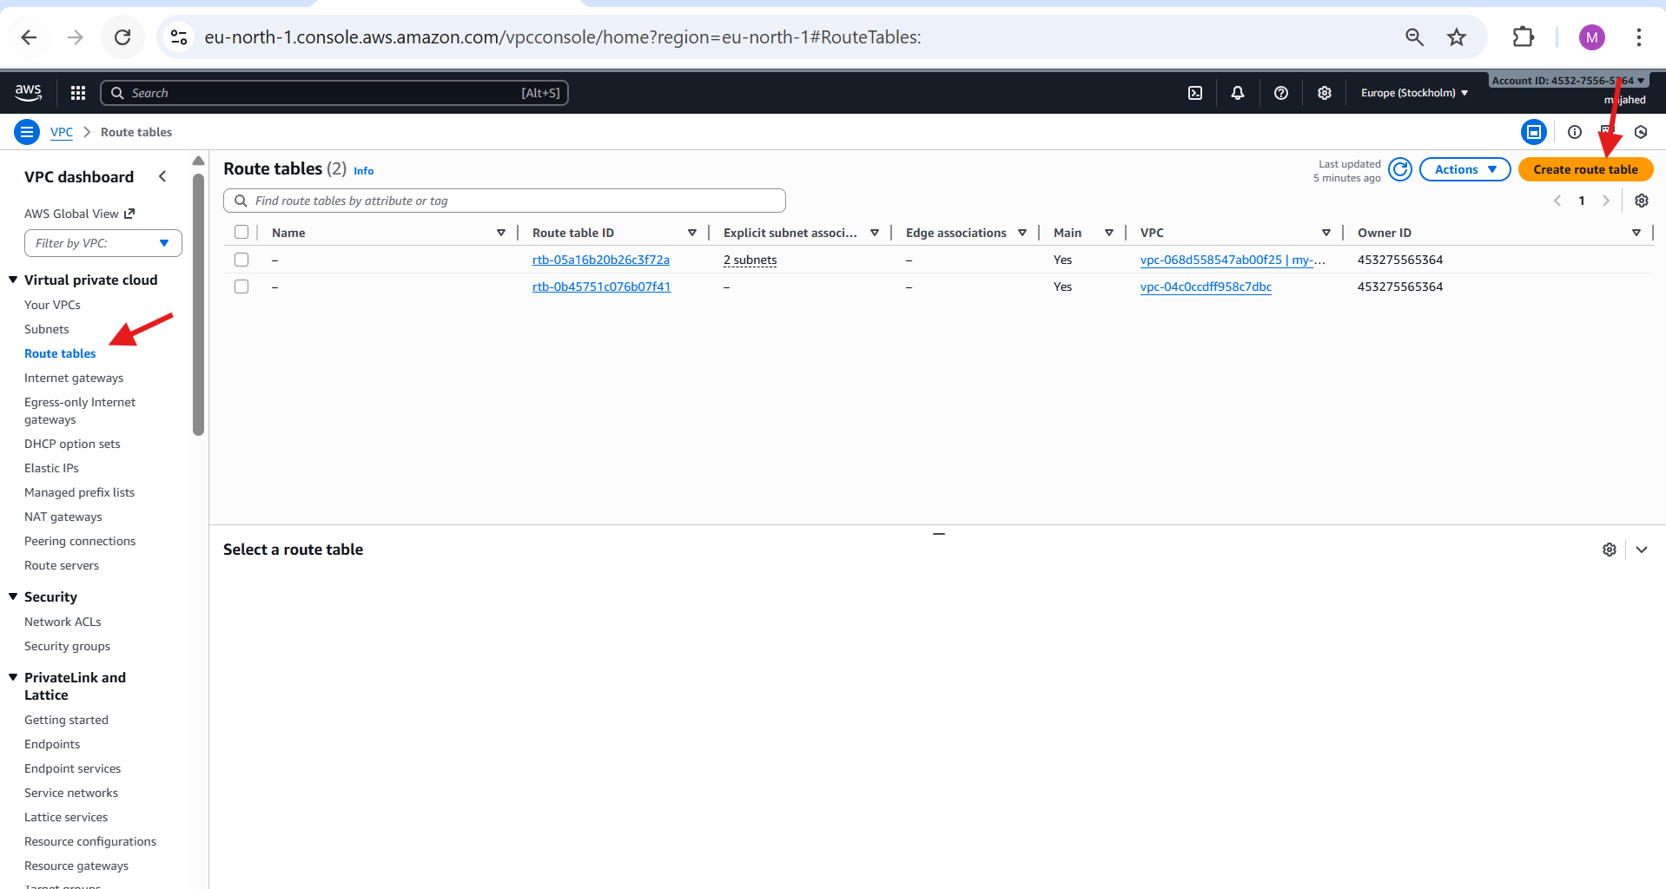

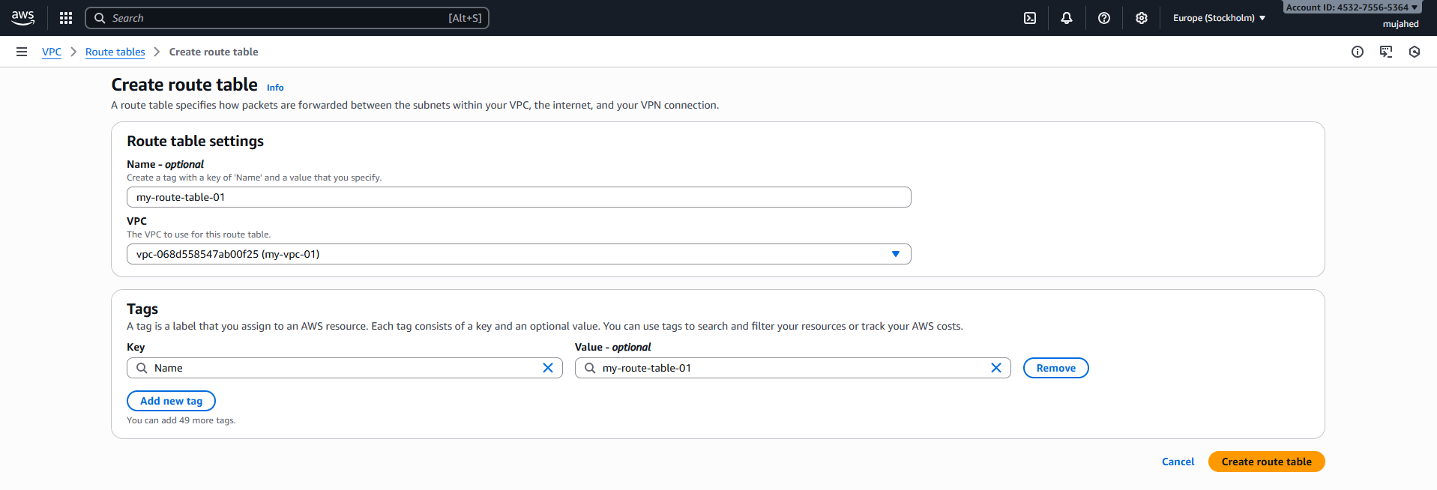

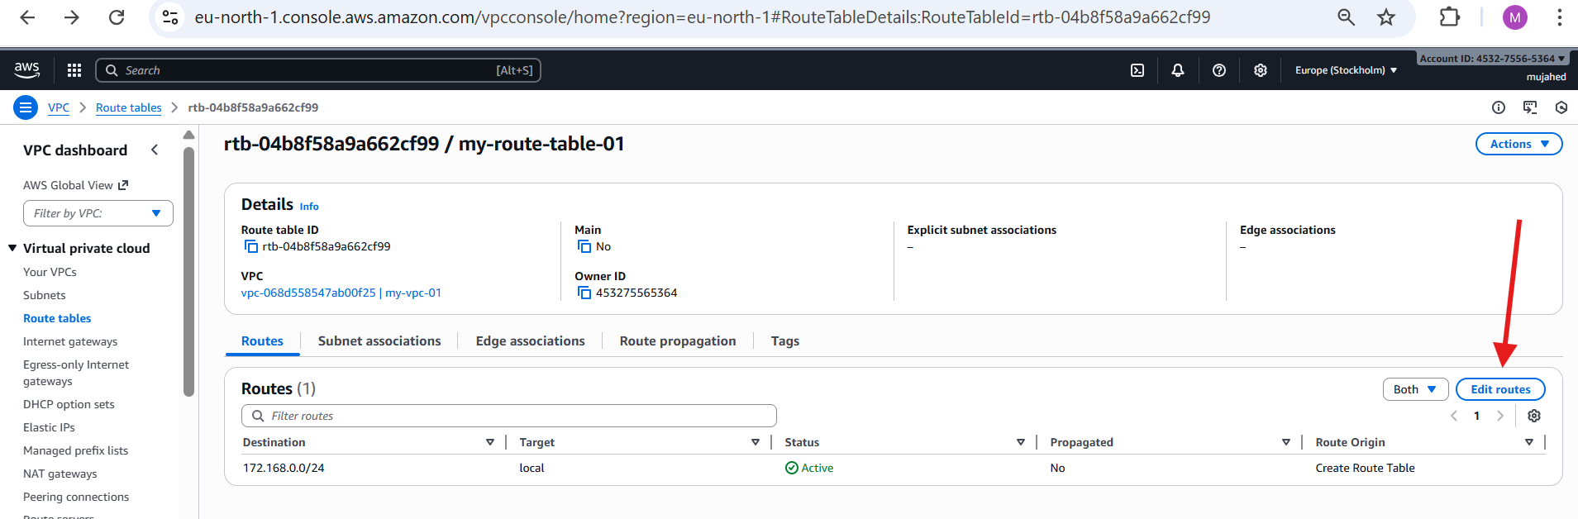

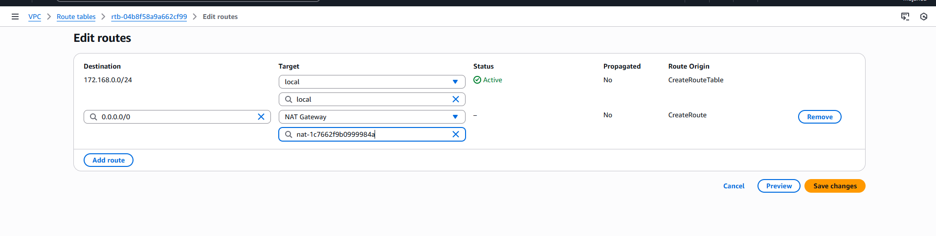

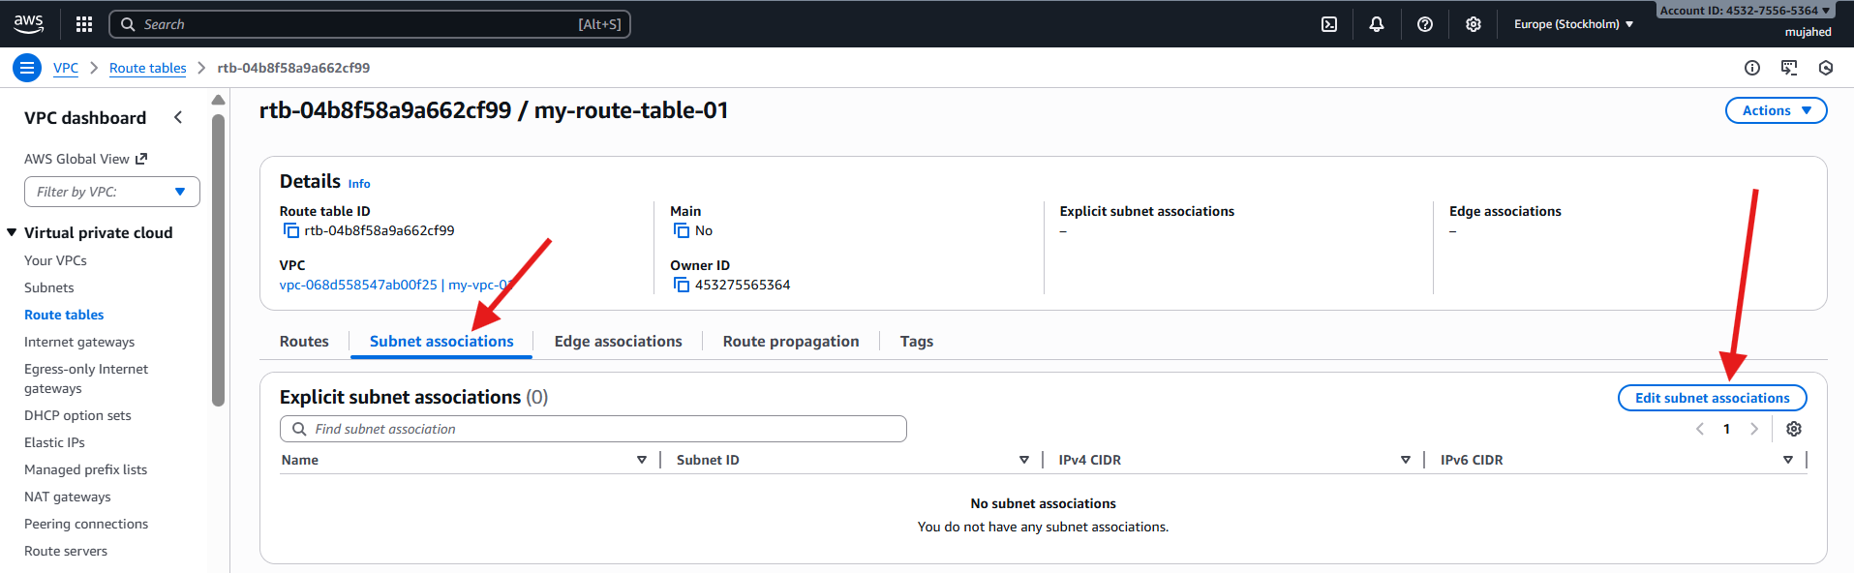

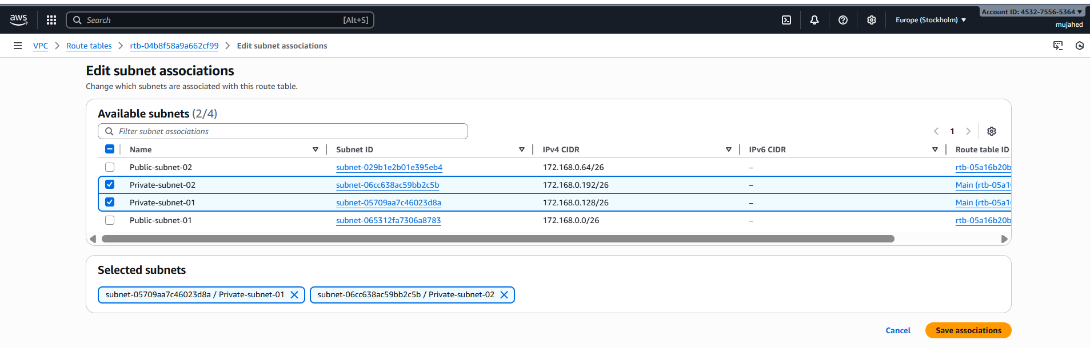

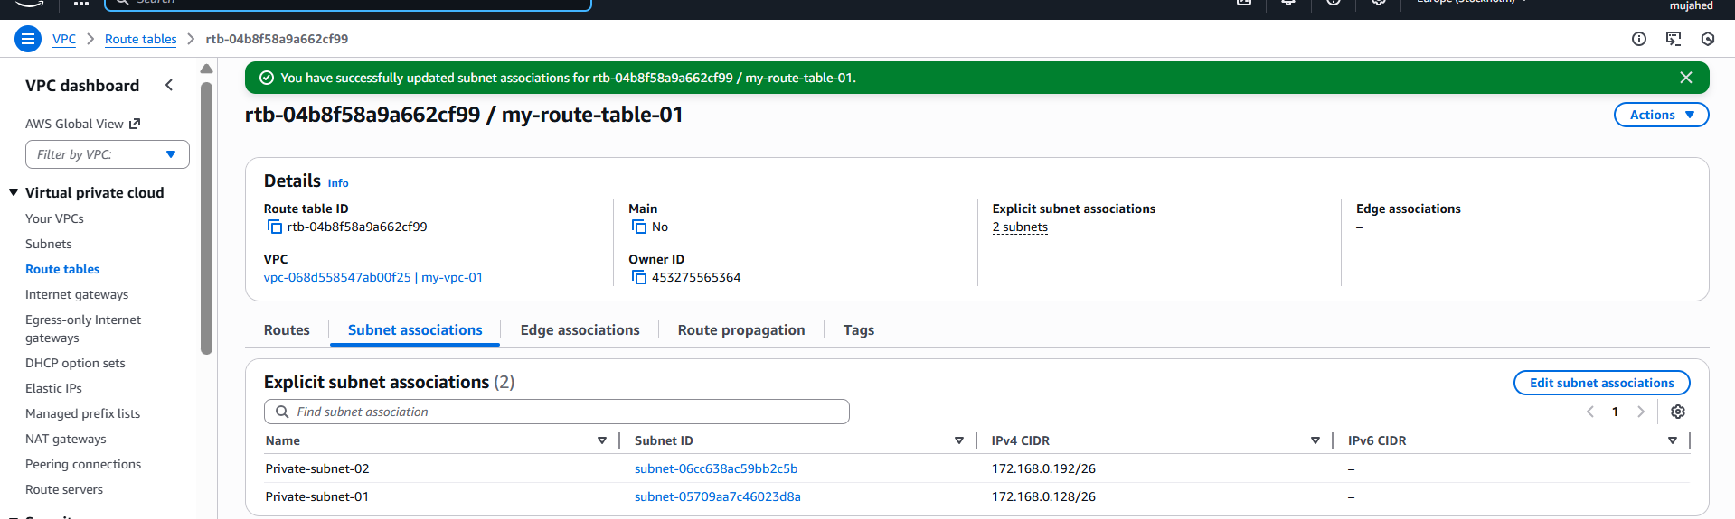

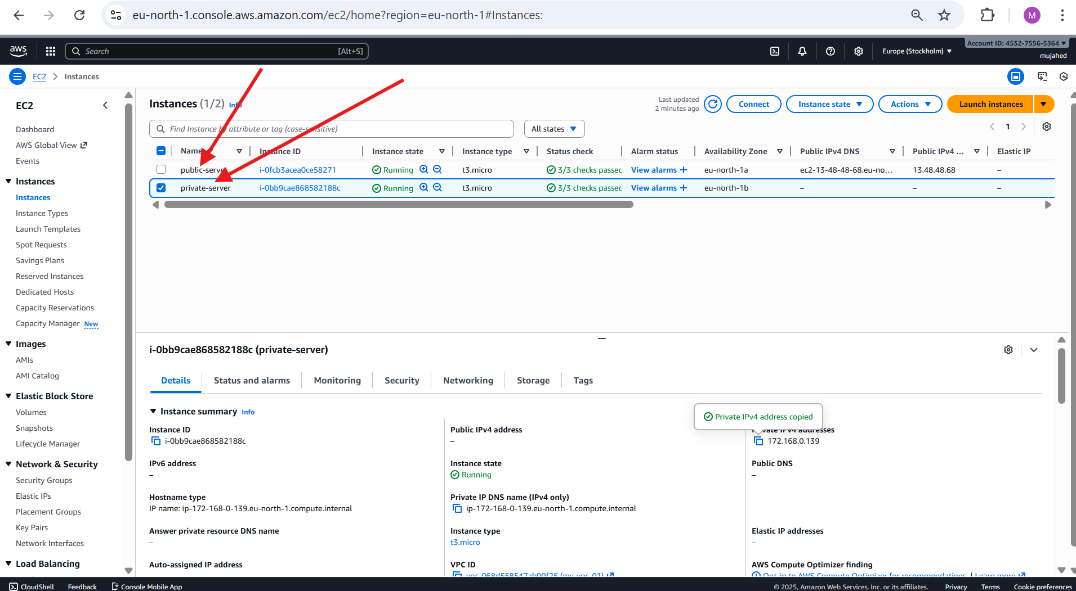

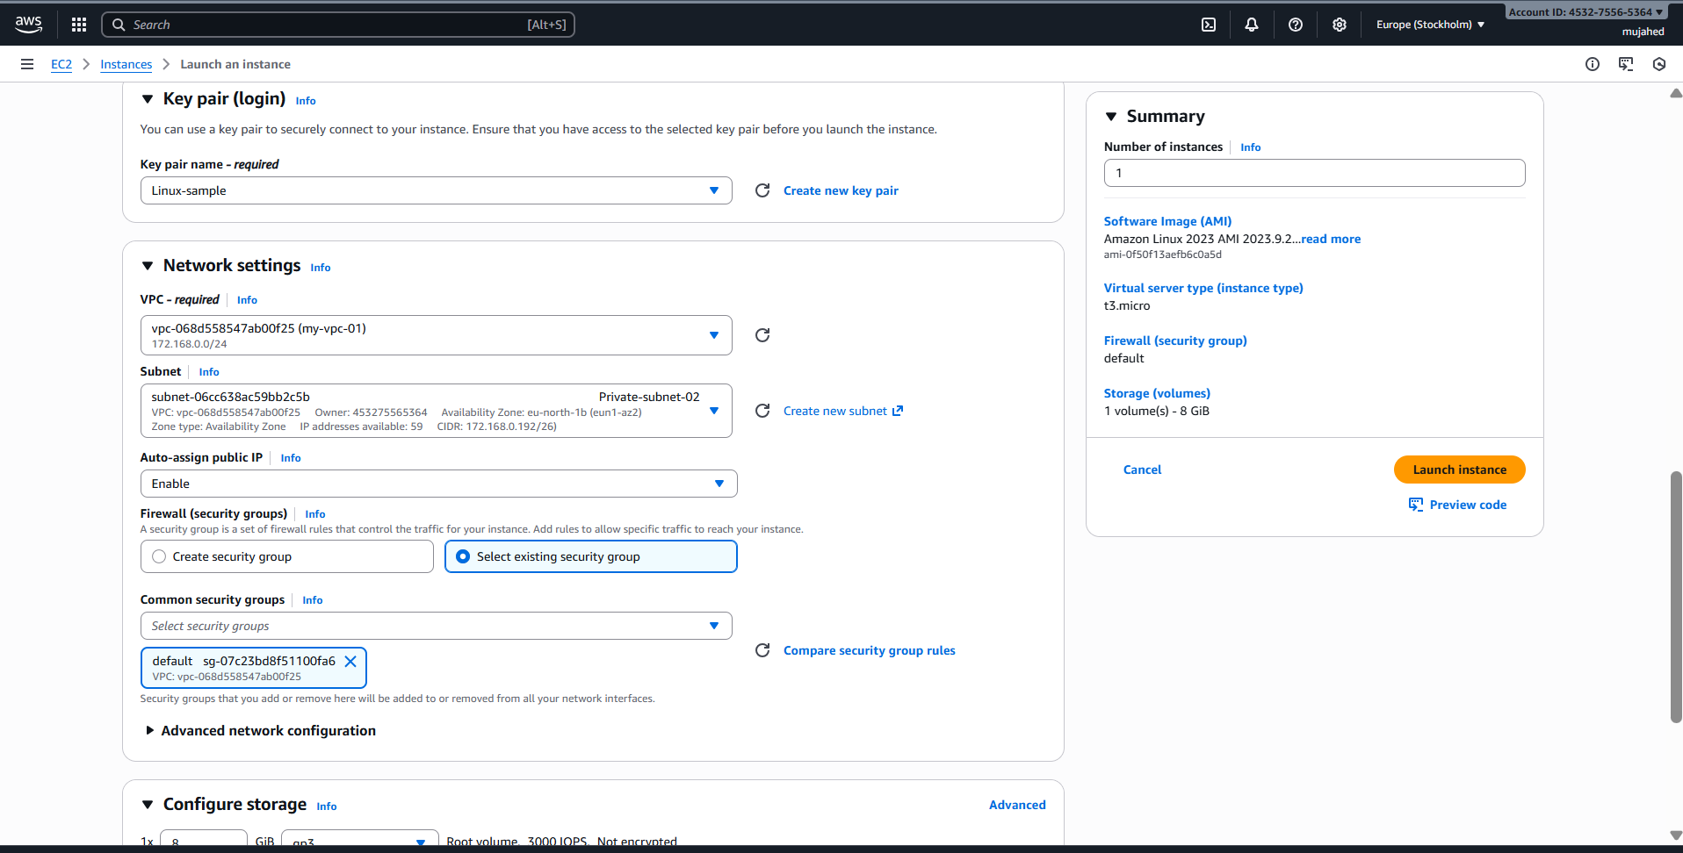

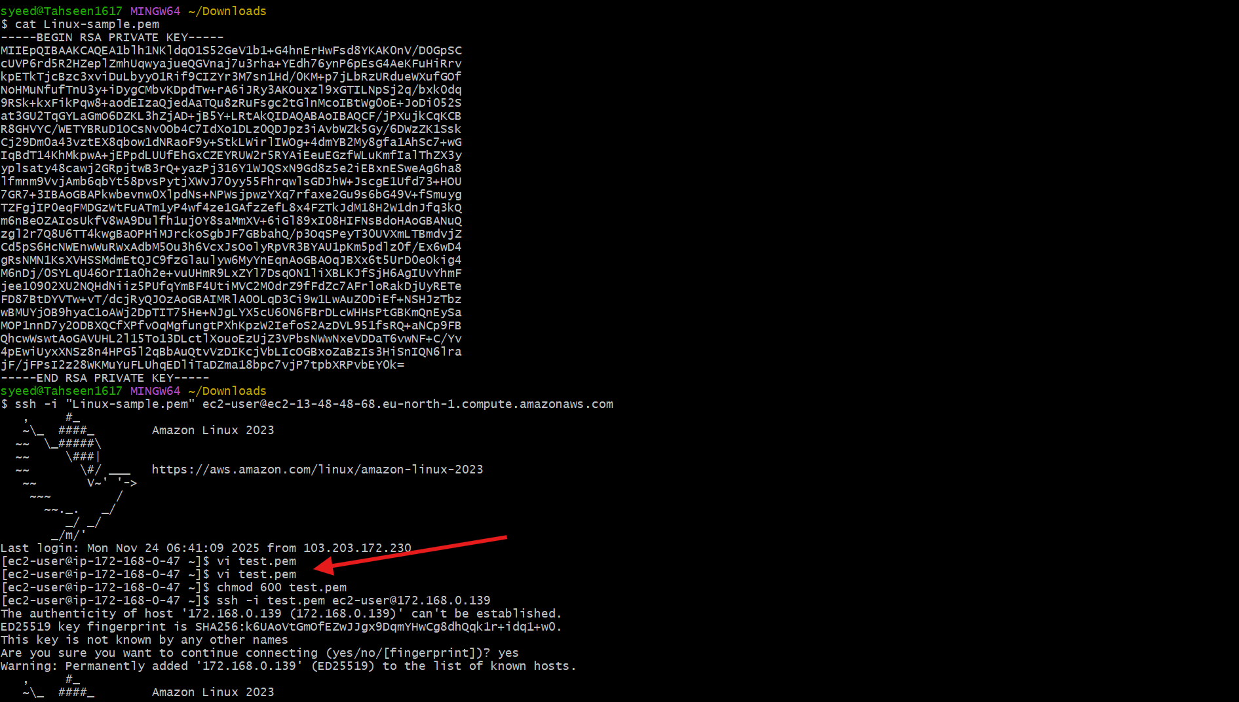

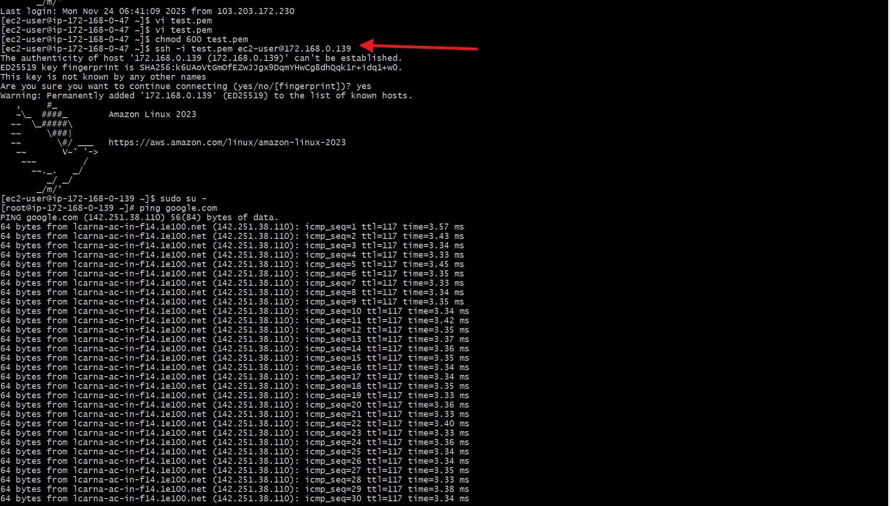

1. Install Apache Tomcat in private EC2 and deploy a sample app.

**1. Initial Connection and Java Installation**

* **Connect to EC2 Instance:** An SSH connection is established to the EC2 instance at IP address 172.168.0.139.
* **Switch to Root User:** The user switches to the root user (sudo su -).
* **Install Java:** The command yum install java-11-amazon-corretto is used to install Amazon Corretto 11 (an OpenJDK distribution). The process shows dependencies being resolved and the transaction summary for the installation.

**2. Download and Extract Apache Tomcat**

* **Navigate to /opt:** The user changes directory to /opt (cd /opt).
* **Download Tomcat:** The command wget https://dlcdn.apache.org/tomcat/tomcat-9/v9.0.112/bin/apache-tomcat-9.0.112.tar.gz downloads the Tomcat 9.0.112 archive.
* **Extract Tomcat:** The command tar xvf apache-tomcat-9.0.112.tar.gz extracts the contents of the archive, creating the apache-tomcat-9.0.112 directory.

**3. Start Tomcat and Check Default Page**

* **Navigate to Tomcat bin:** The user changes directory to the Tomcat binary directory (cd apache-tomcat-9.0.112/bin).
* **Start Tomcat:** The command ./startup.sh starts the Apache Tomcat server. The output confirms that Tomcat has started.
* **Check Tomcat Default Page:**
  + The user navigates to the webapps directory (cd ../webapps).
  + The command curl http://172.168.0.139:8080/ is used to check the default Tomcat welcome page on port 8080.
  + The output shows the HTML content of the Tomcat welcome page, confirming the server is running and accessible.

**4. Deploy Sample Application (sample.war)**

* **Navigate to webapps:** The user is in the Tomcat webapps directory.
* **Download Sample WAR:** The command wget https://tomcat.apache.org/tomcat-9.0-doc/appdev/sample/sample.war downloads the standard Tomcat sample web application archive (sample.war).
* **Deployment:** Tomcat automatically deploys the .war file, creating a new directory named sample inside webapps.
* **Verification of Deployment:** The ls command shows the newly deployed sample directory along with sample.war. The user then checks the contents of the sample directory.

**5. Access the Deployed Sample Application**

* **Access Sample Application:** The command curl http://172.168.0.139:8080/sample is executed to access the newly deployed sample application.
* The output of the curl command (not fully visible, but implied by the command itself) would show the HTML content returned by the sample application, confirming successful deployment and access.

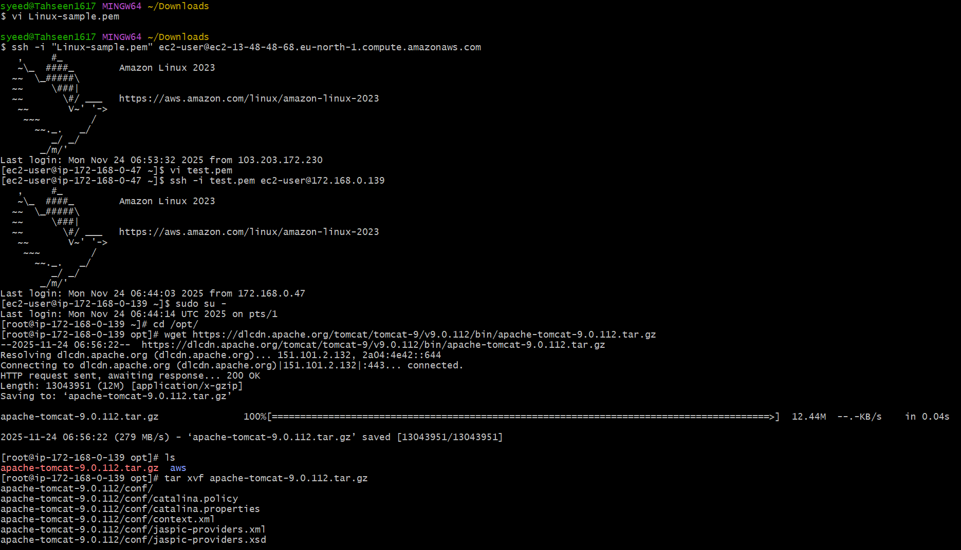

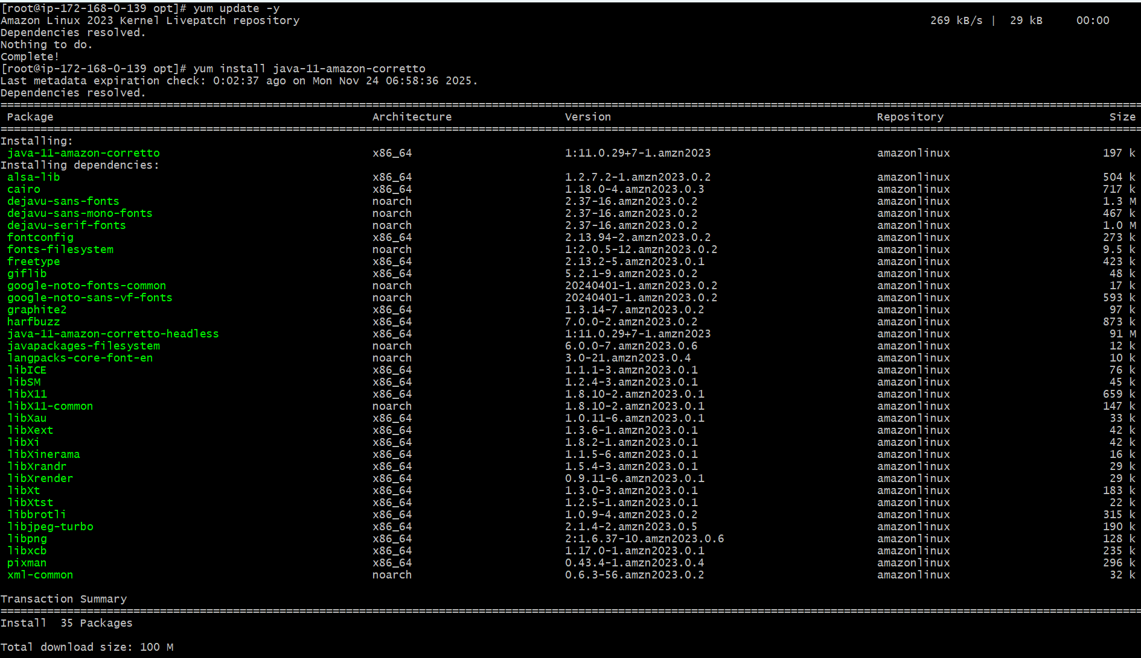

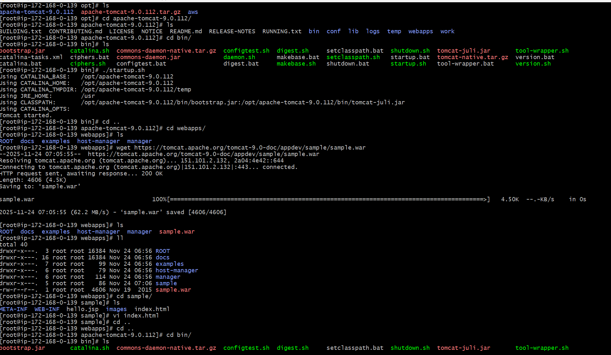

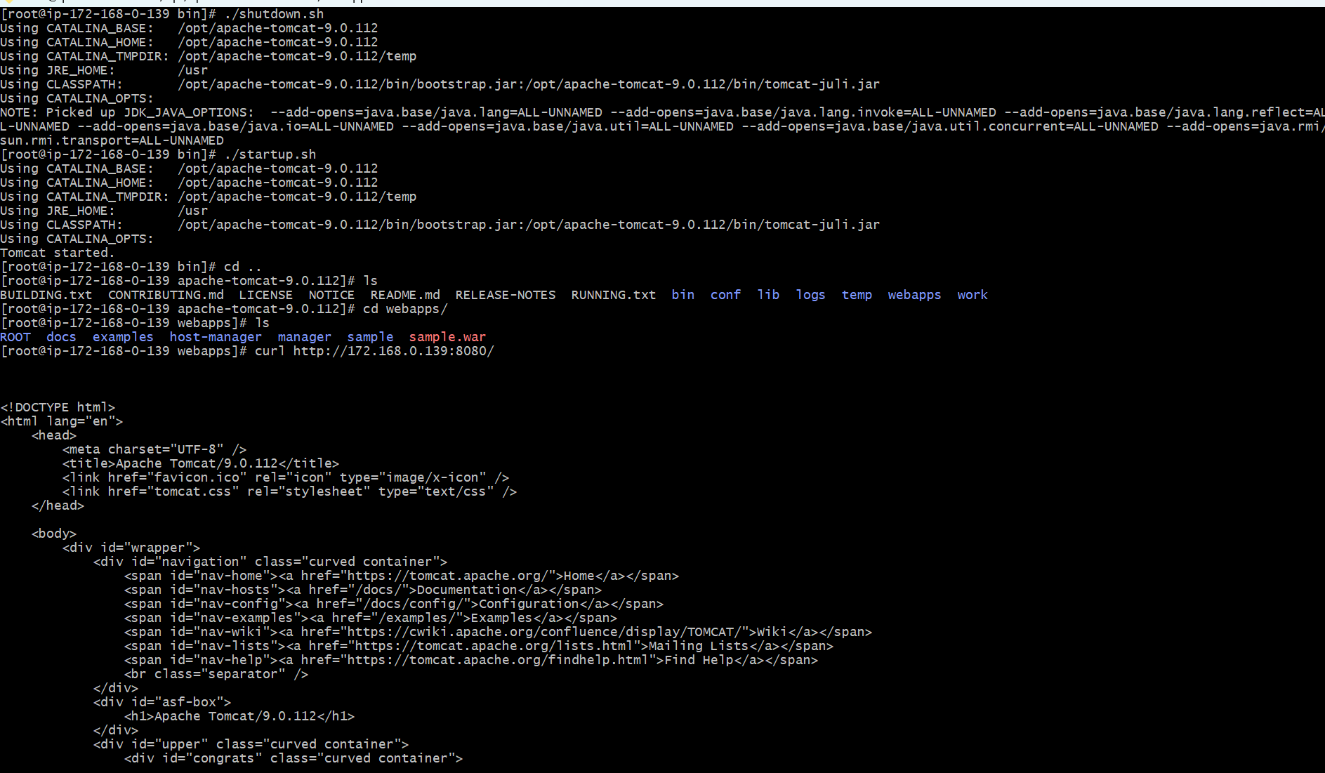

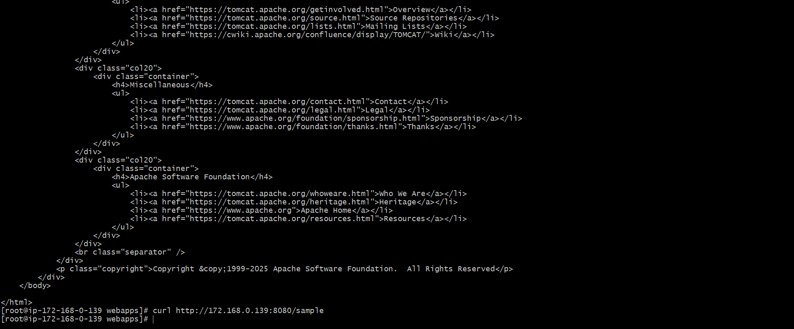

1. Configure VPC flow logs and store the logs in S3 and CloudWatch.

**Step 1: Open VPC Console**

* Go to AWS Console → **VPC**
* Click **Your VPCs**
* Select your VPC:

**Step 2: Create Flow Log**

* Click **Actions → Create flow log**

**1. Name (optional)**

my-flowlog-1

**2. Filter (Traffic to capture)**

Choose:

All

These captures **accepted + rejected** traffic.

**3. Maximum aggregation interval**

Choose:

10 minutes

(1 minute is optional for detailed logging.)

**4. Destination**

Choose:

Send to CloudWatch Logs

**5. Destination log group**

Enter a new log group name:

/vpc/flowlogs

(AWS will create it automatically if it does not exist.)

**6. Service access**

Choose:

Create and use a new service role

AWS will automatically create a role like:

vpc-flow-logs-role

Under **Service role**, you will see:

Choose a role → vpc-flow-logs-role

Select it.

**7. Log record format**

Choose:

AWS default format

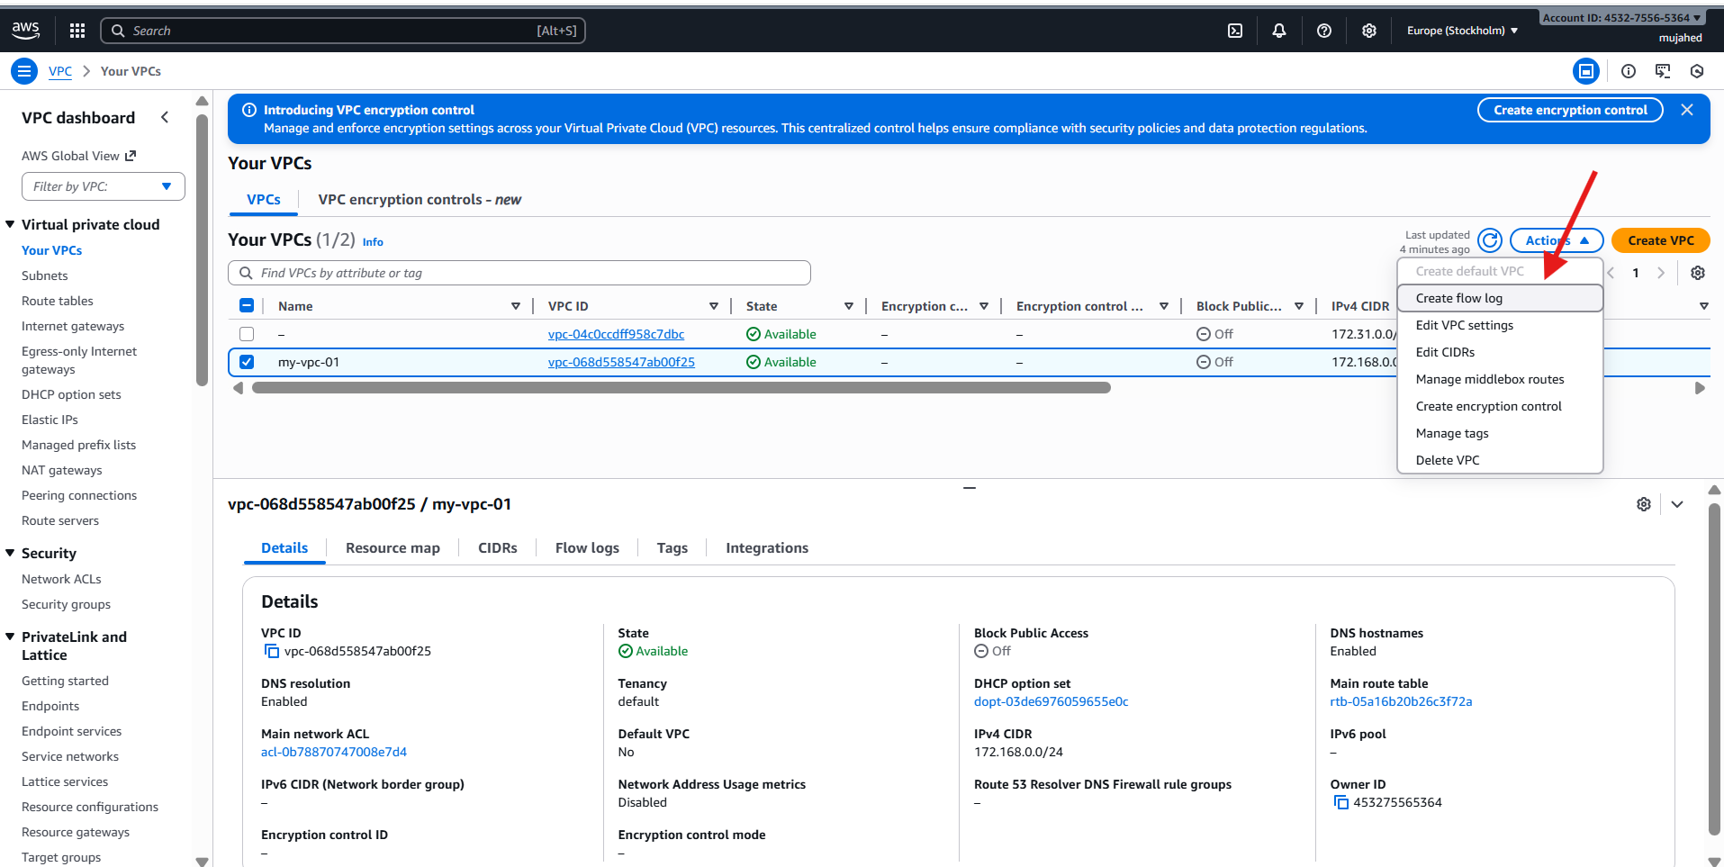

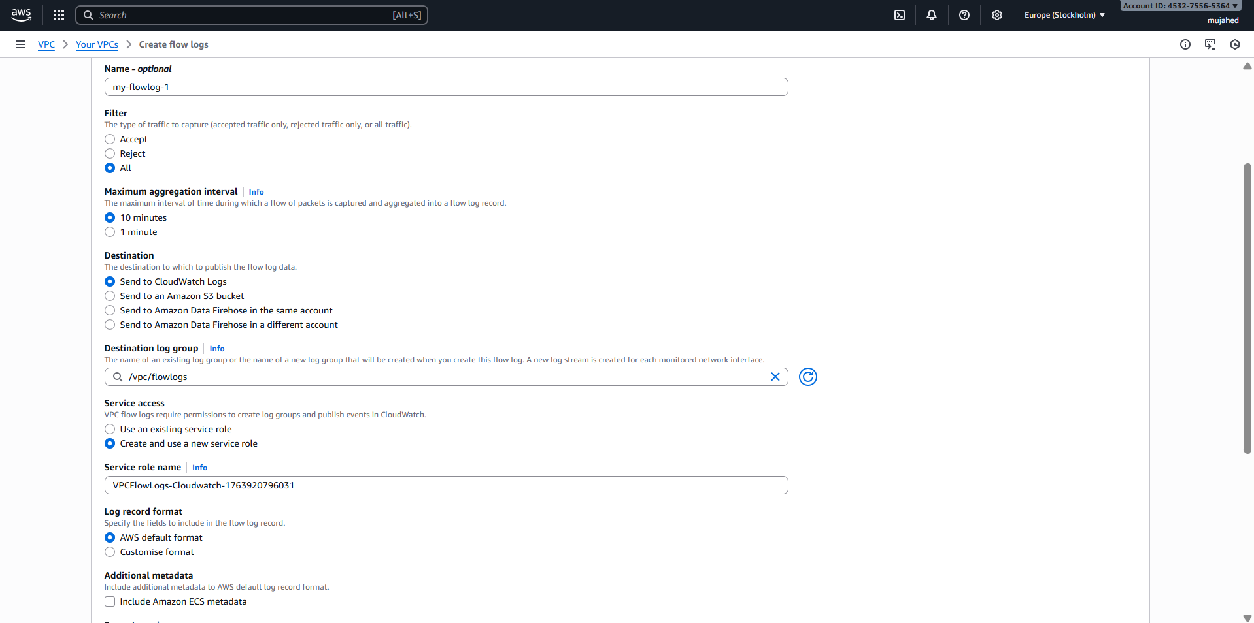

* **Open CloudWatch**

Go to AWS Console → Search for **CloudWatch** → Open it.

* **In the left sidebar, click "Logs"**

You will see several options under "Logs":

* Log groups
* Log streams
* Logs Insights

Click **Log groups**.

**Search for your log group**

In the log groups page, there is a **Search bar** at the top.

